Discover Sri Lanka with INTRO TRAVELS INDIA
Sri Lanka, known as the “Pearl of the Indian Ocean,” is a breathtaking island nation famous for its golden beaches, lush tea plantations, ancient temples, wildlife safaris, scenic train journeys, and rich cultural heritage. From tropical coastlines to misty mountains, Sri Lanka offers the perfect combination of adventure, relaxation, and cultural exploration.
Whether you are planning a honeymoon, family holiday, solo getaway, or group tour, Sri Lanka is one of the best international destinations close to India.

Why Visit Sri Lanka?
- Beautiful beaches & tropical resorts
- Scenic hill stations & tea gardens
- Rich Buddhist heritage & ancient temples
- Wildlife safaris & national parks
- Affordable luxury travel
- Famous train journeys
- Delicious Sri Lankan cuisine
- Warm hospitality & vibrant culture

Top Tourist Attractions in Sri Lanka
1. Colombo – The Vibrant Capital
Sri Lanka’s capital city combines modern lifestyle with colonial charm.
Top attractions:
- Galle Face Green
- Gangaramaya Temple
- Colombo Lotus Tower
- Shopping & nightlife
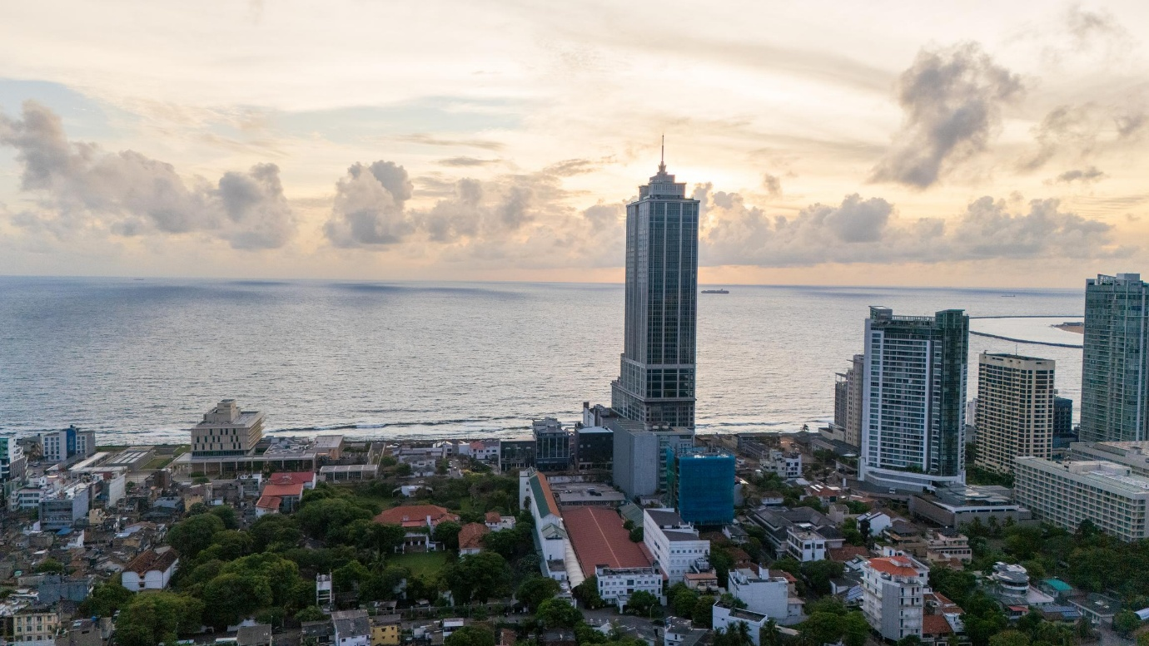
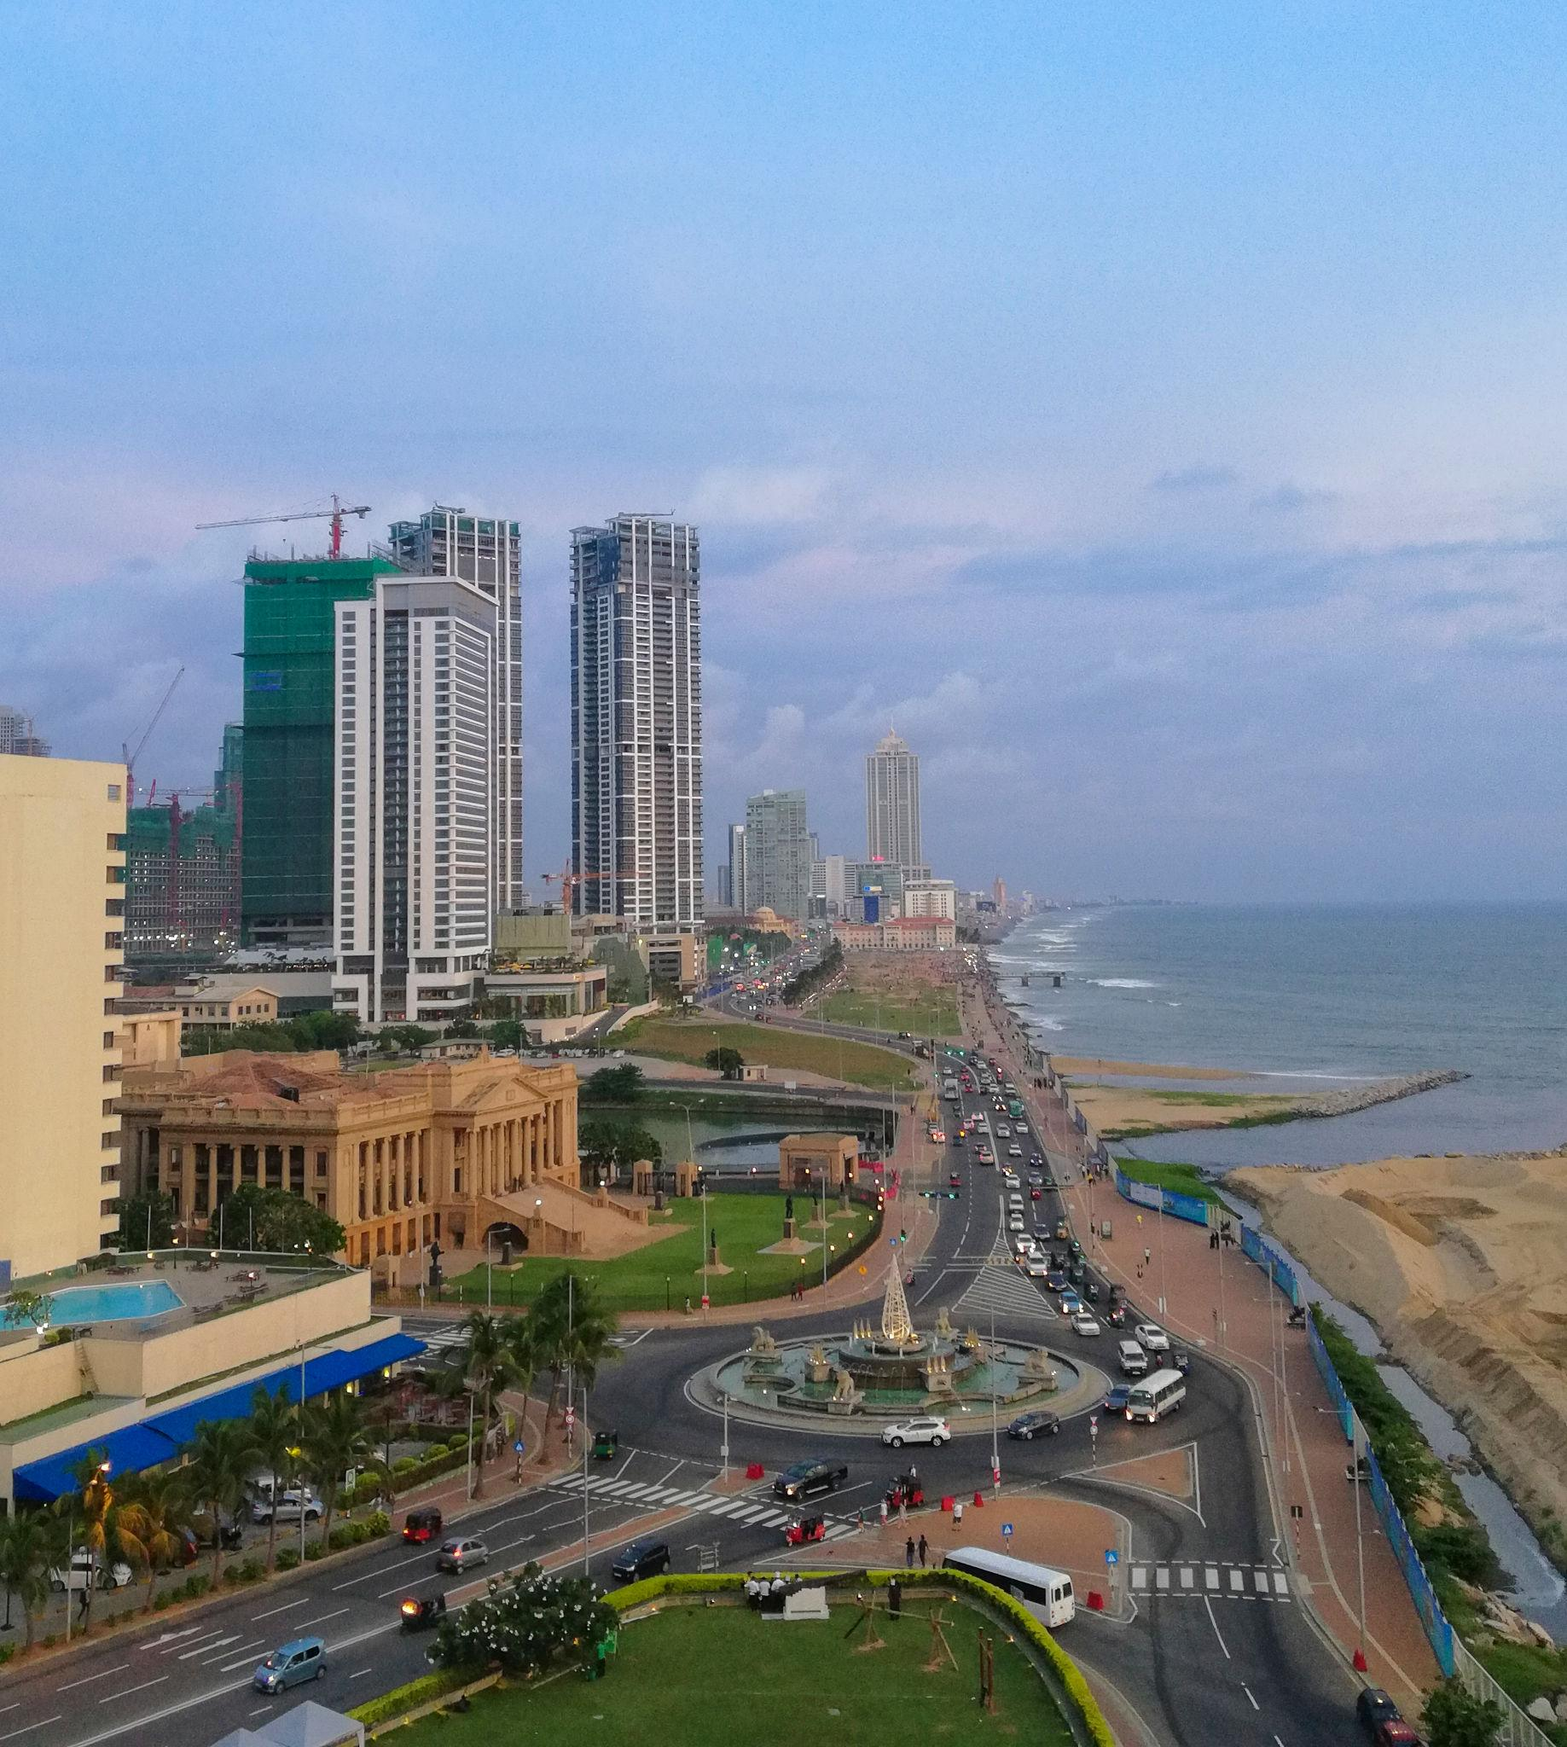
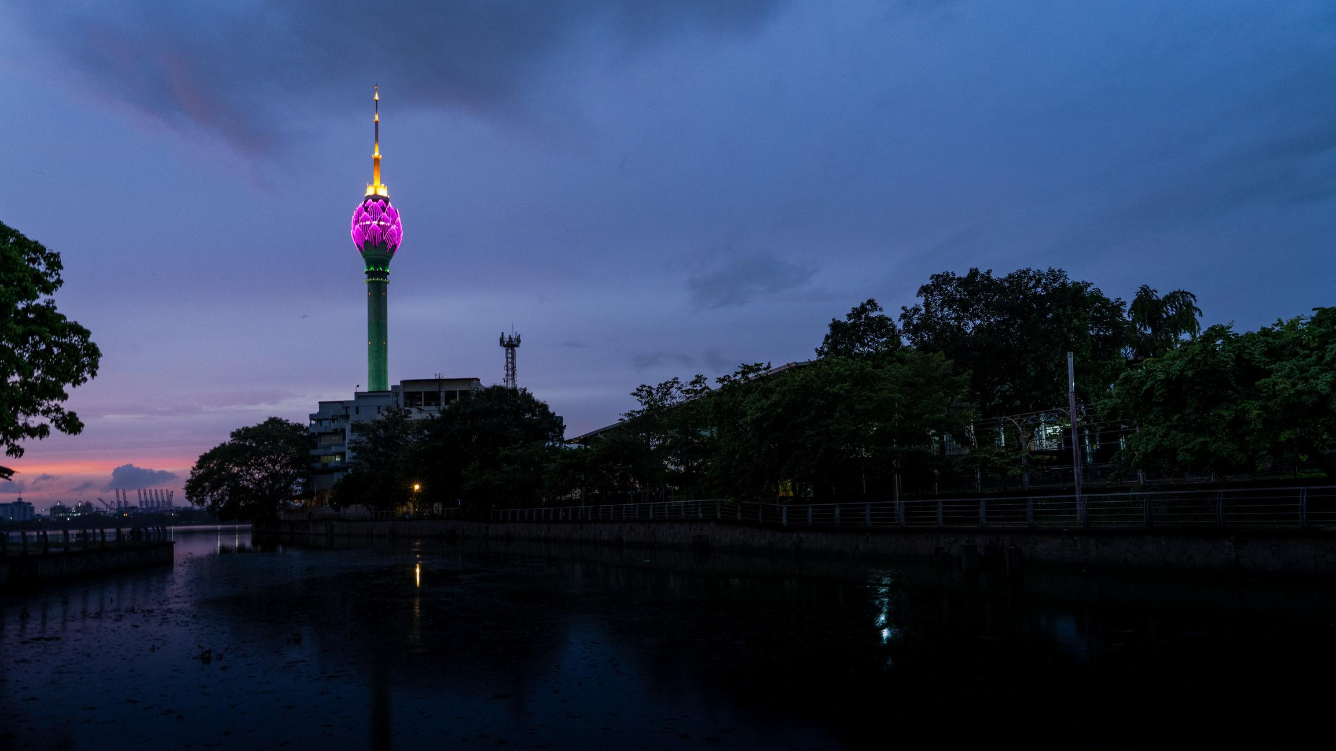
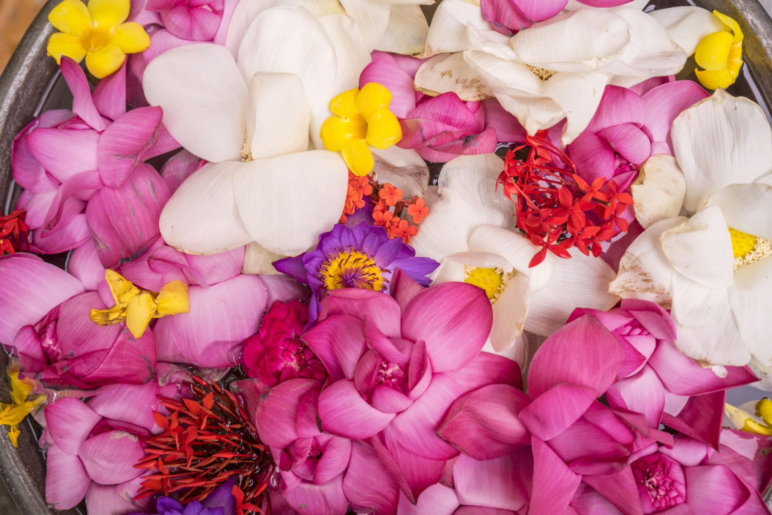

2. Sigiriya Rock Fortress
A UNESCO World Heritage Site and one of Sri Lanka’s most iconic landmarks.
Highlights:
- Ancient rock fortress
- Stunning panoramic views
- Historic frescoes
- Beautiful gardens
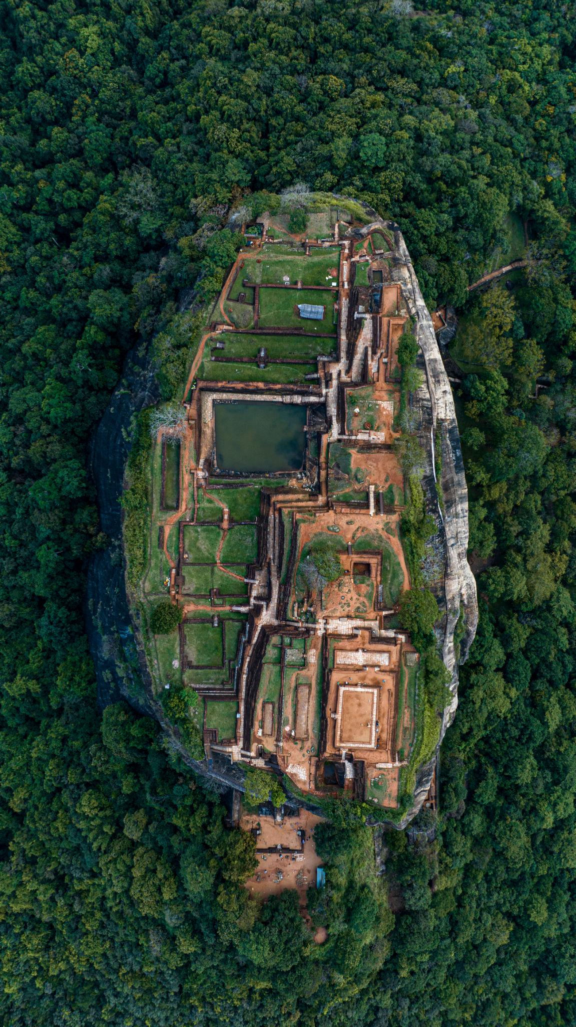
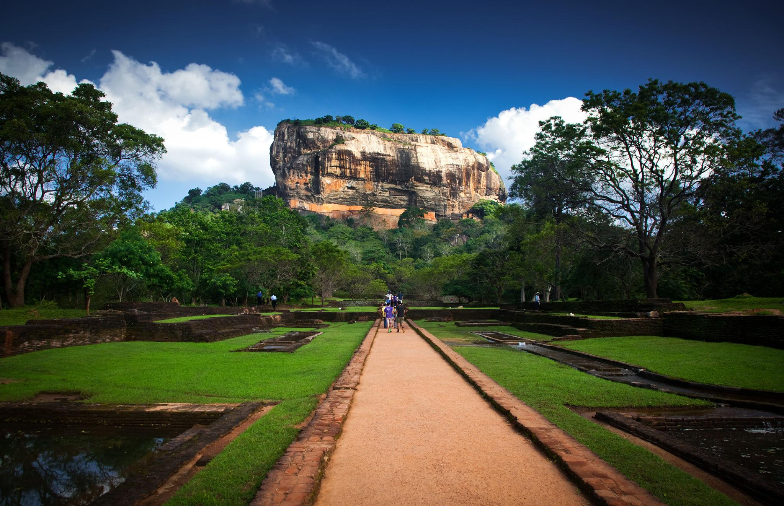
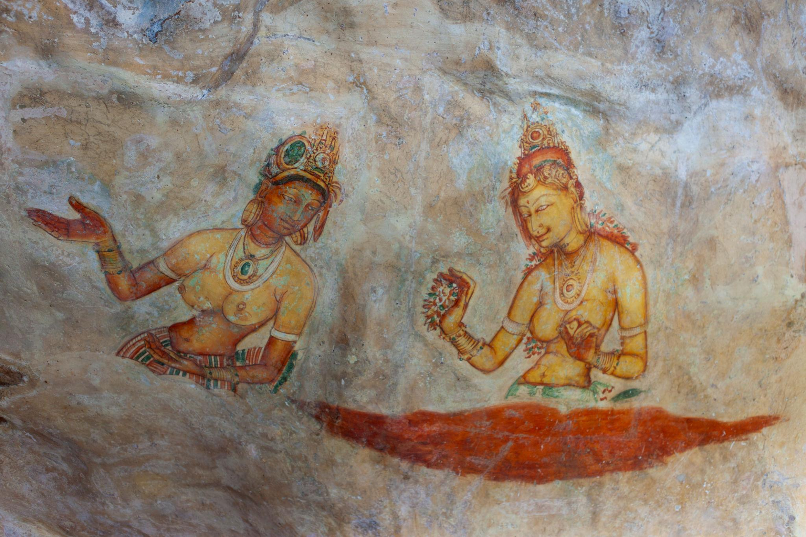

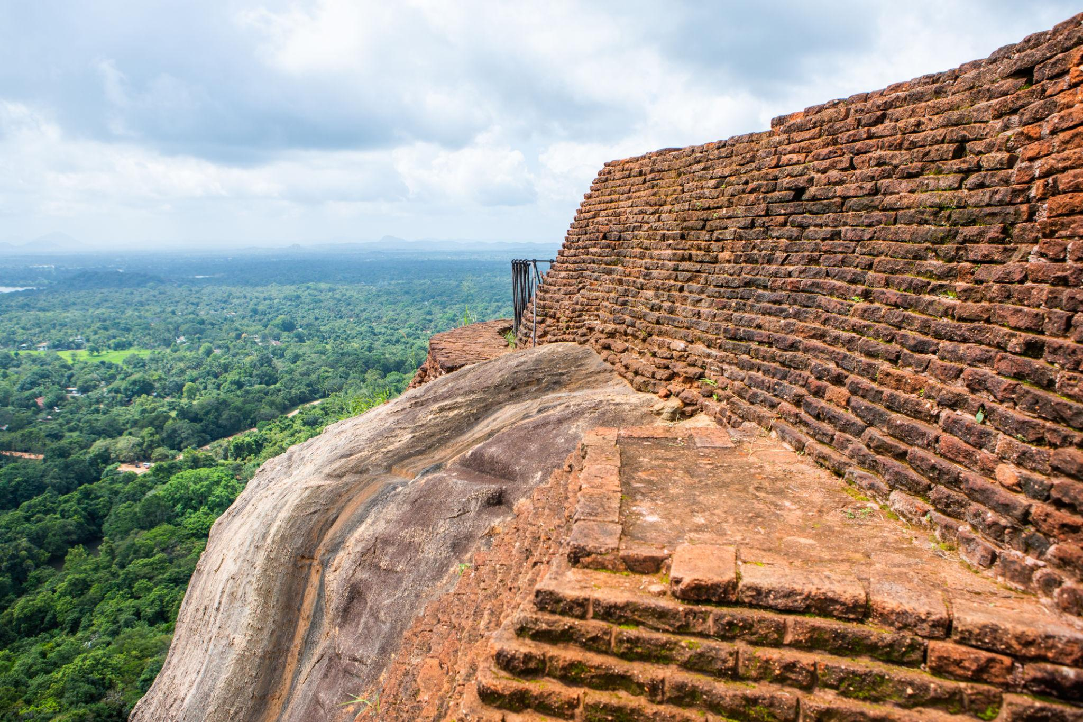
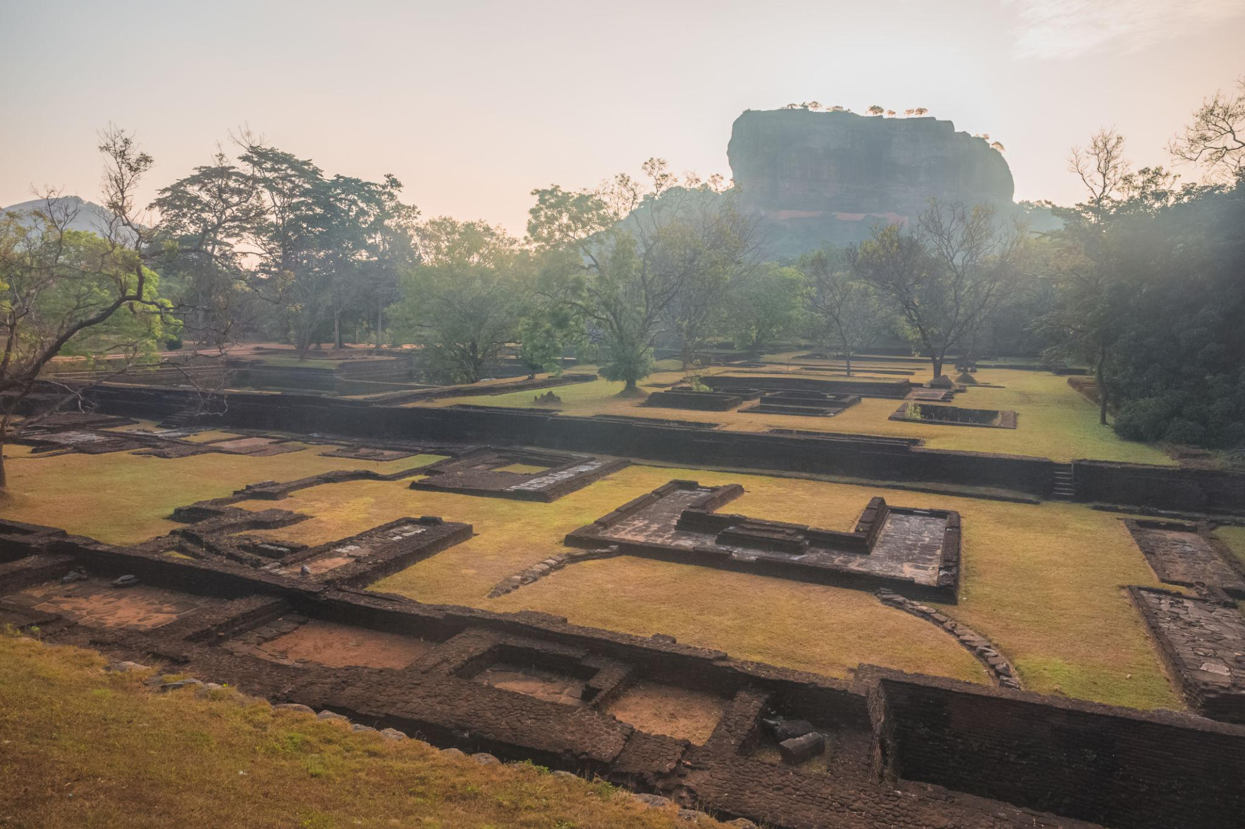
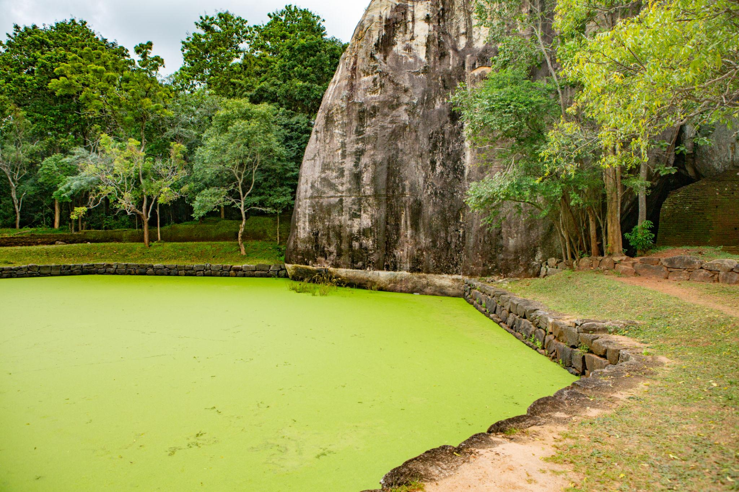
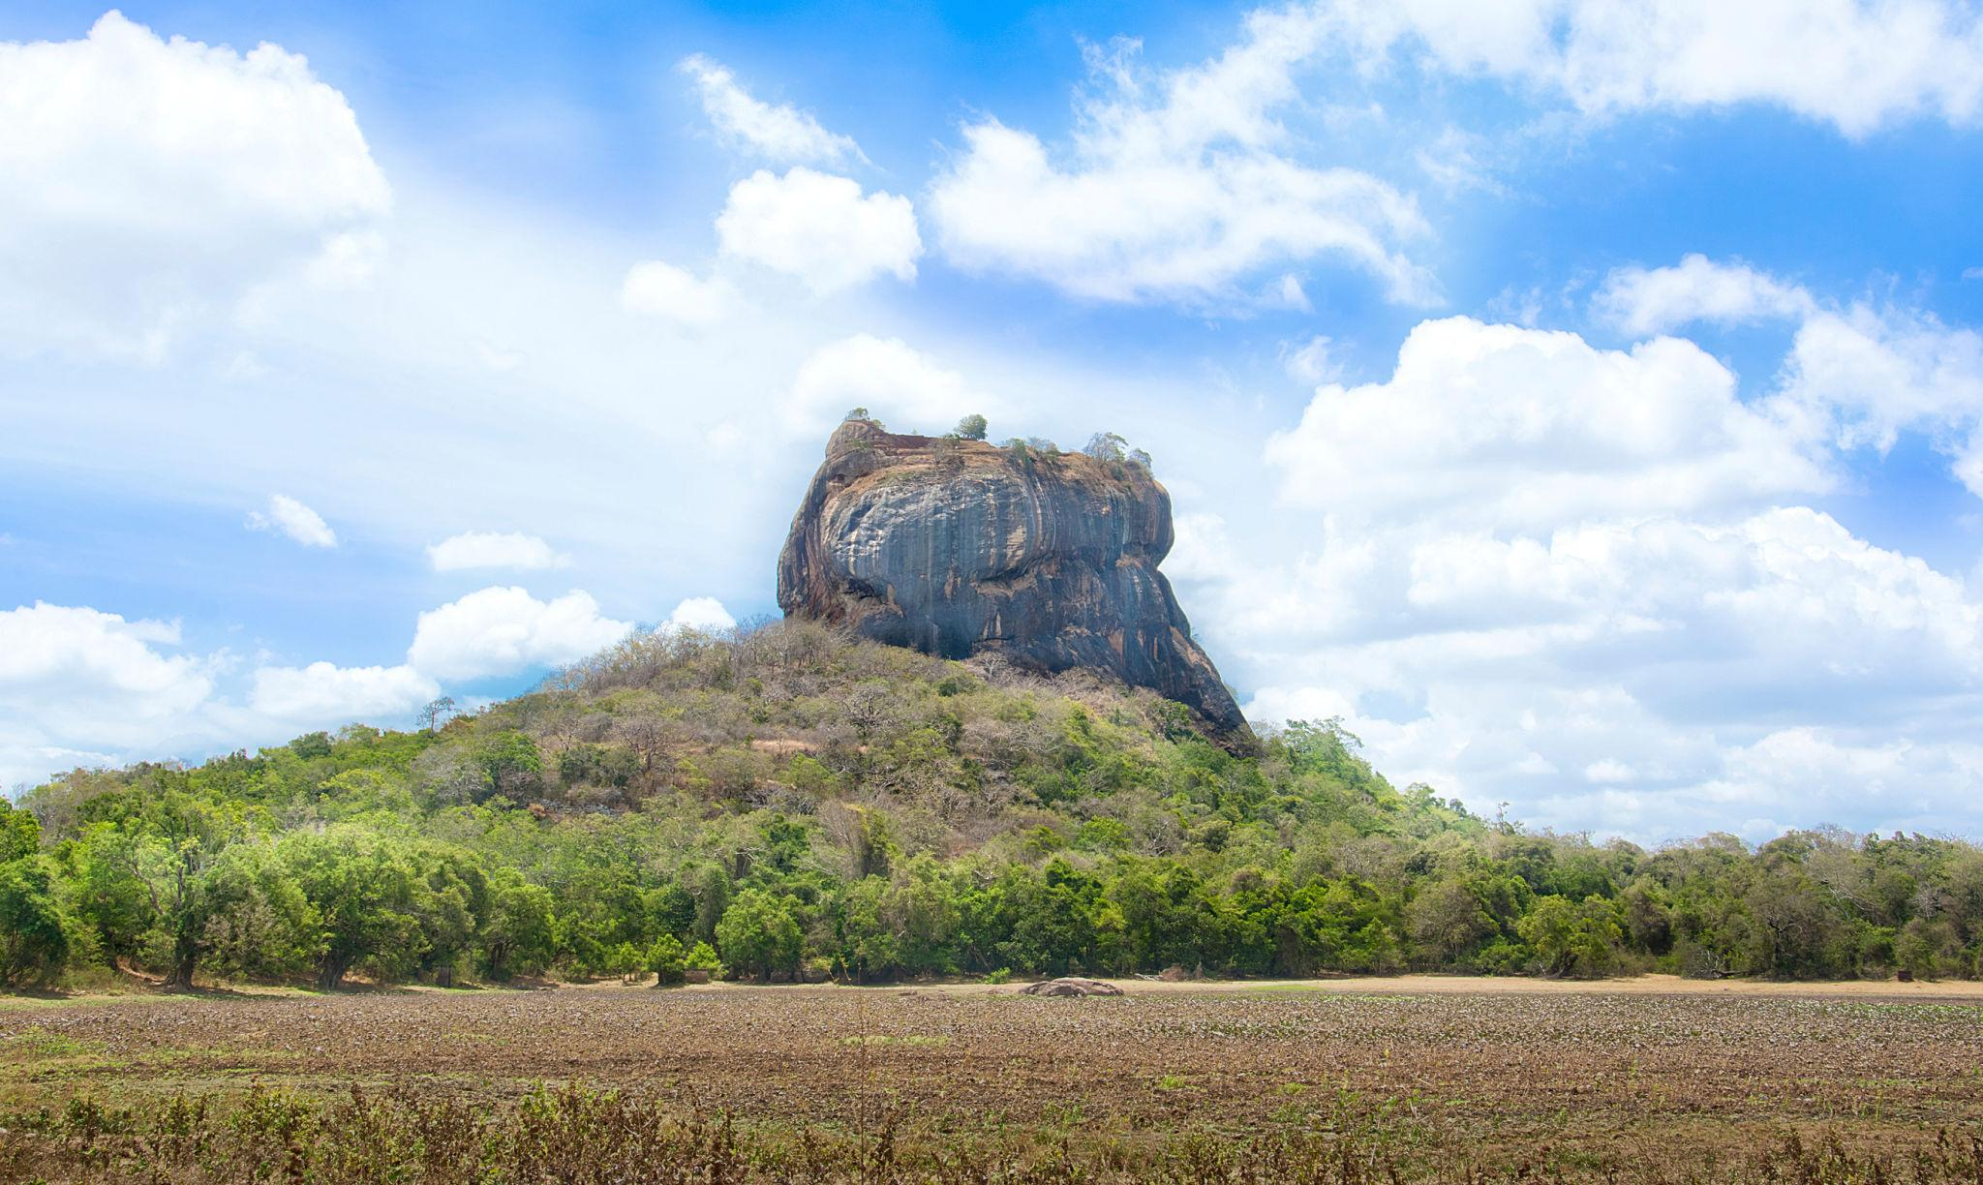

3. Kandy
A beautiful hill city known for spirituality and nature.
Must visit:
- Temple of the Tooth Relic
- Kandy Lake
- Cultural dance performances
- Botanical Gardens
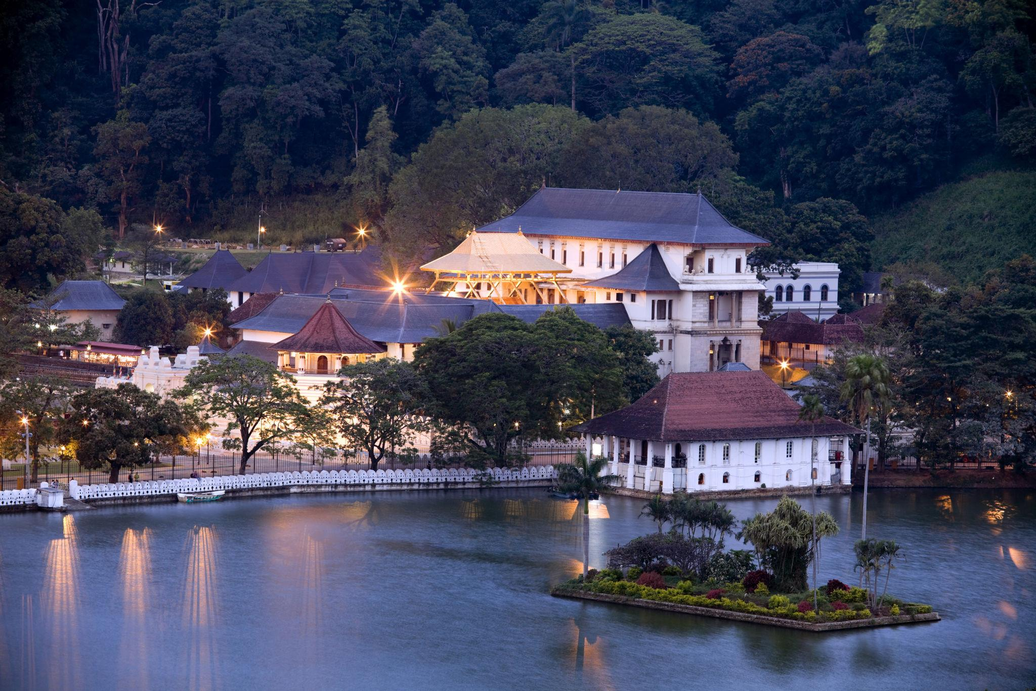
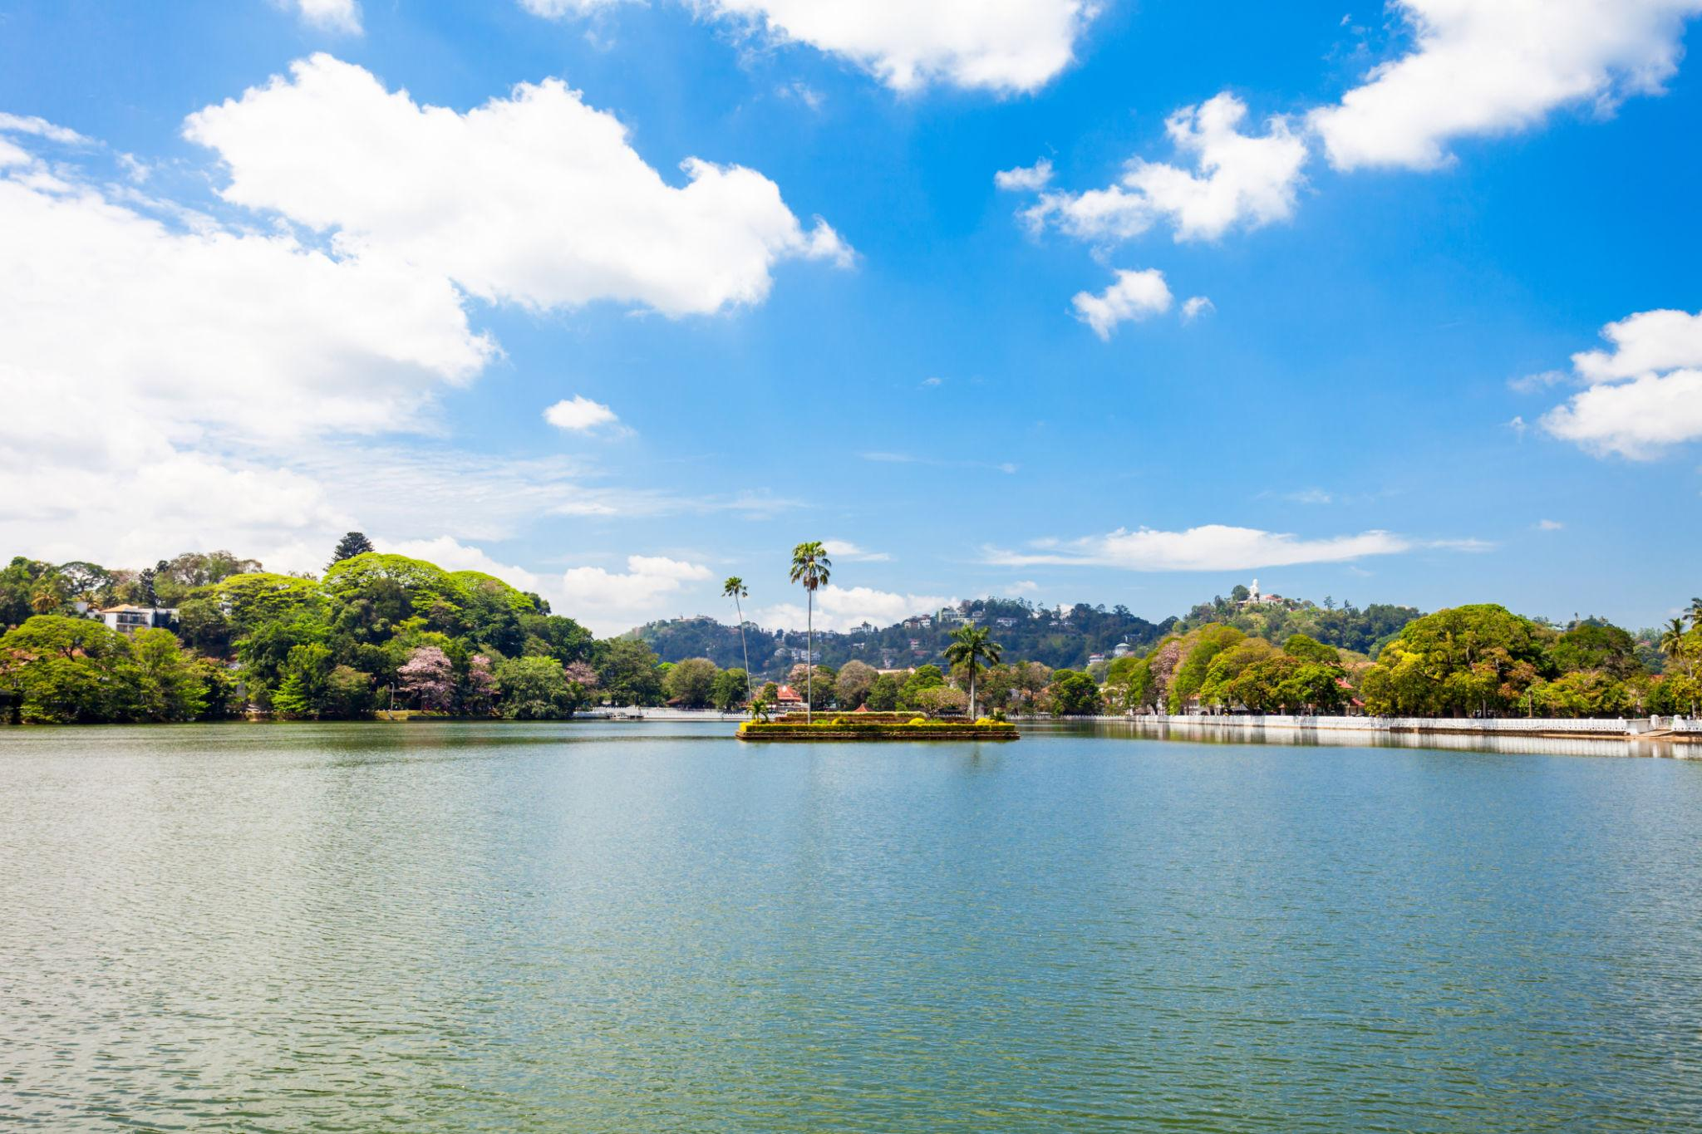
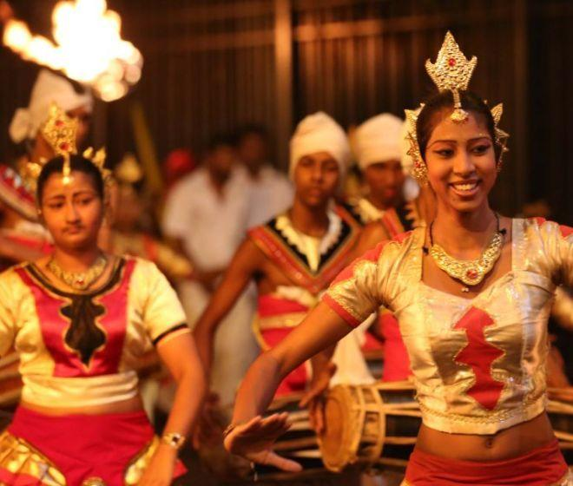
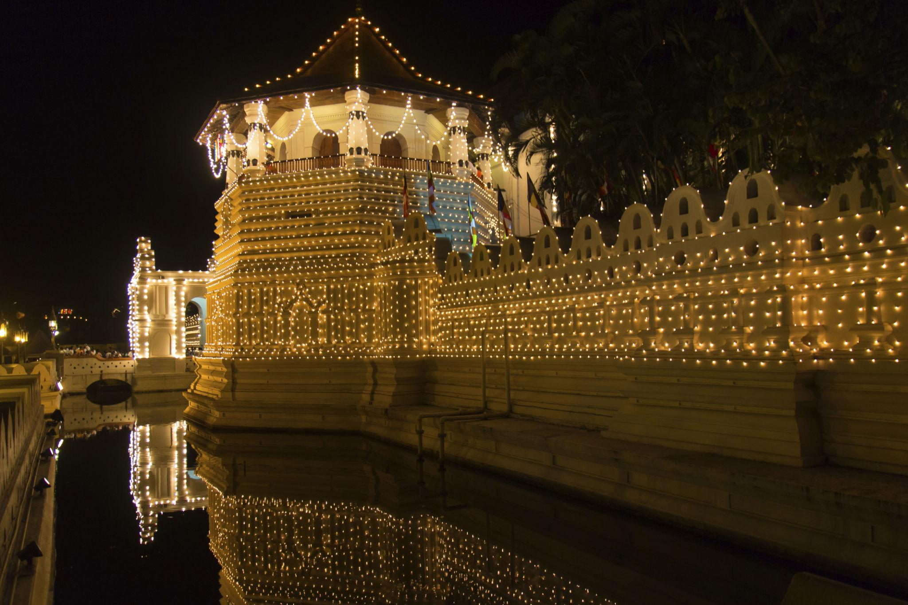
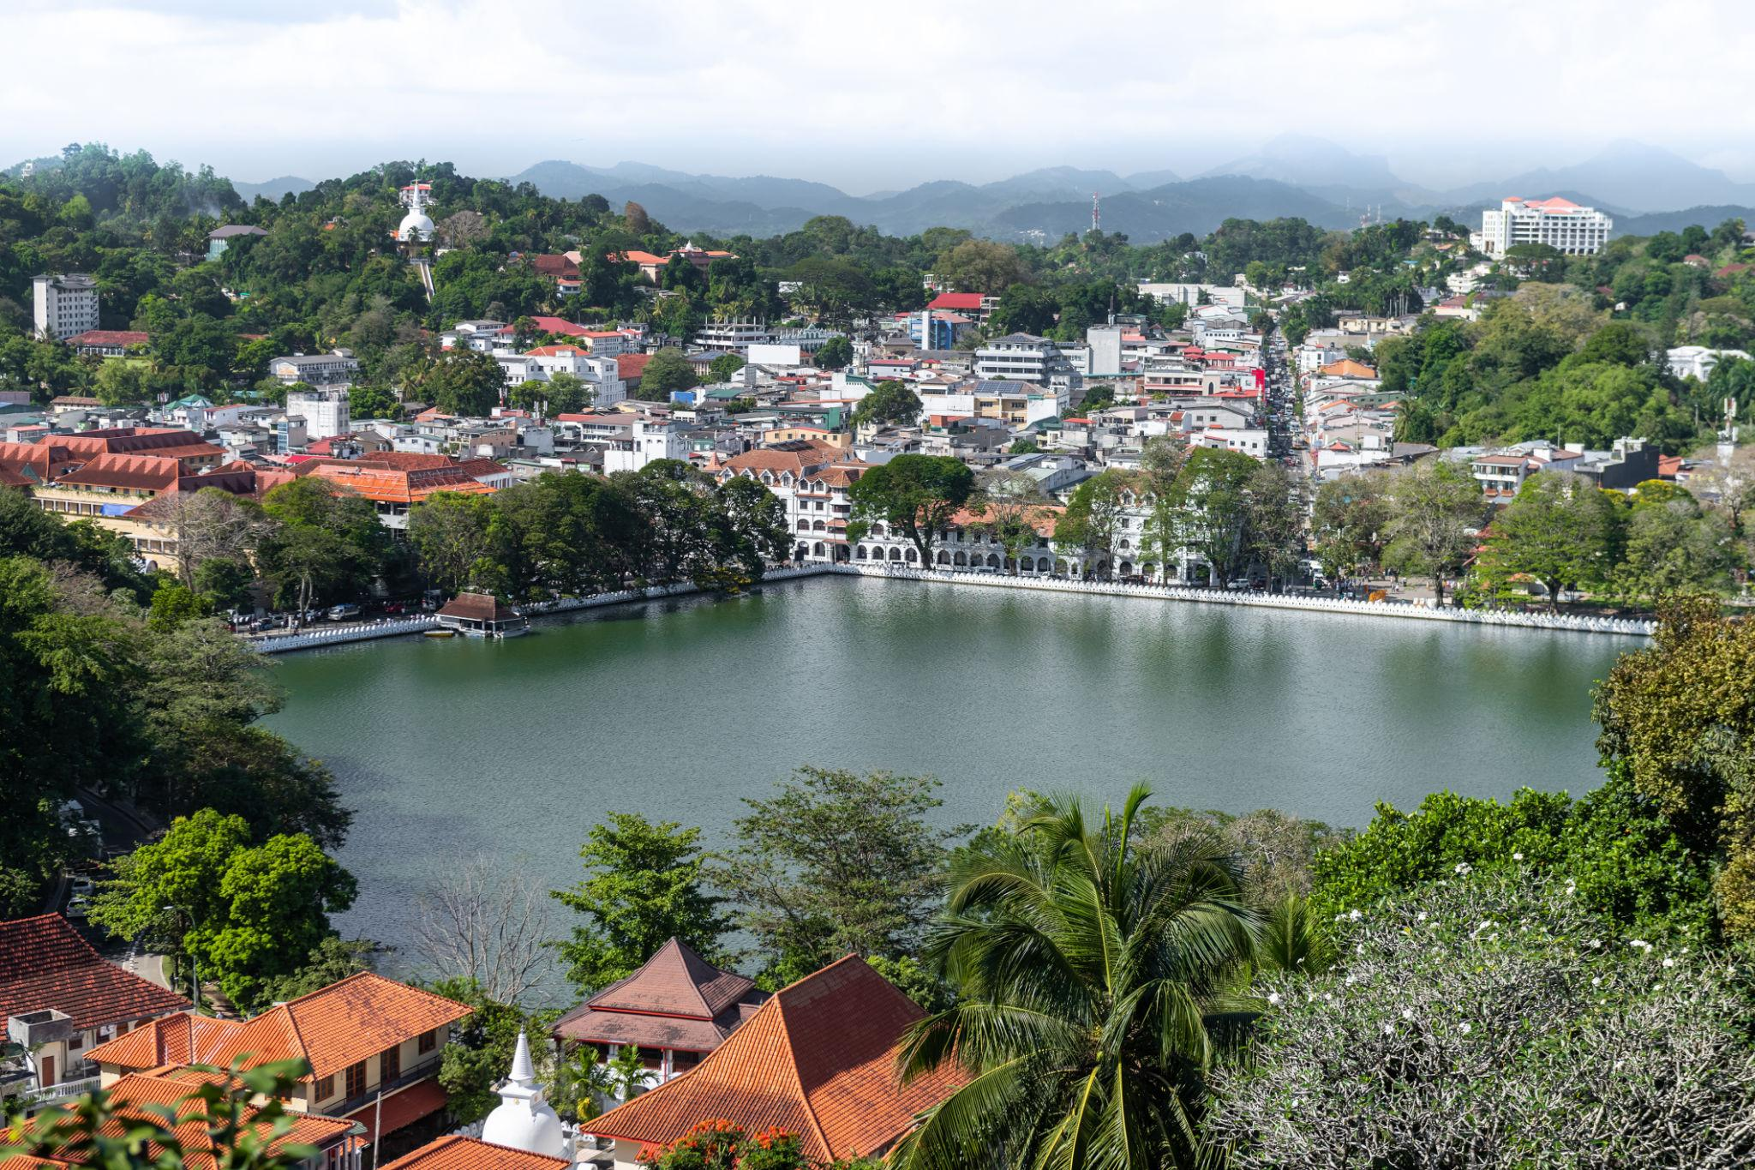
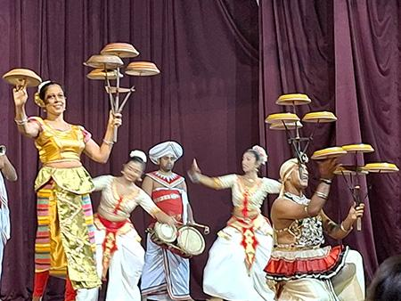

4. Nuwara Eliya – Tea Plantation Paradise
Known as “Little England” because of its cool climate and colonial architecture.
Famous for:
- Tea plantations
- Scenic train rides
- Waterfalls
- Mountain landscapes
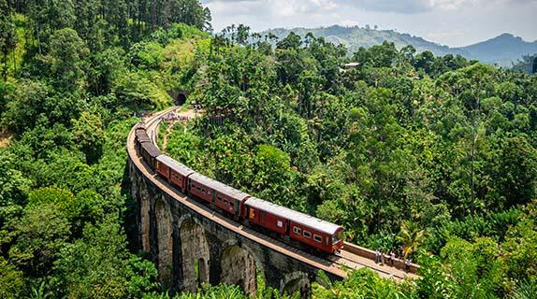
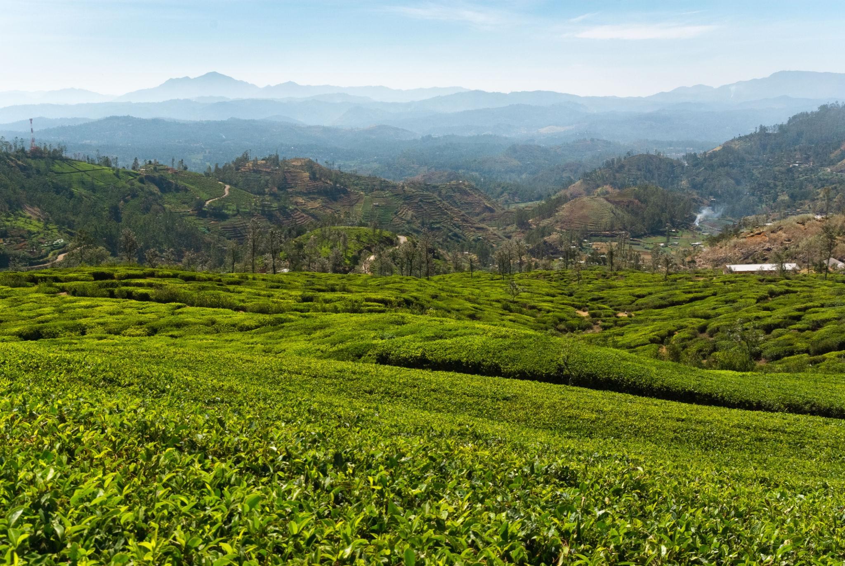
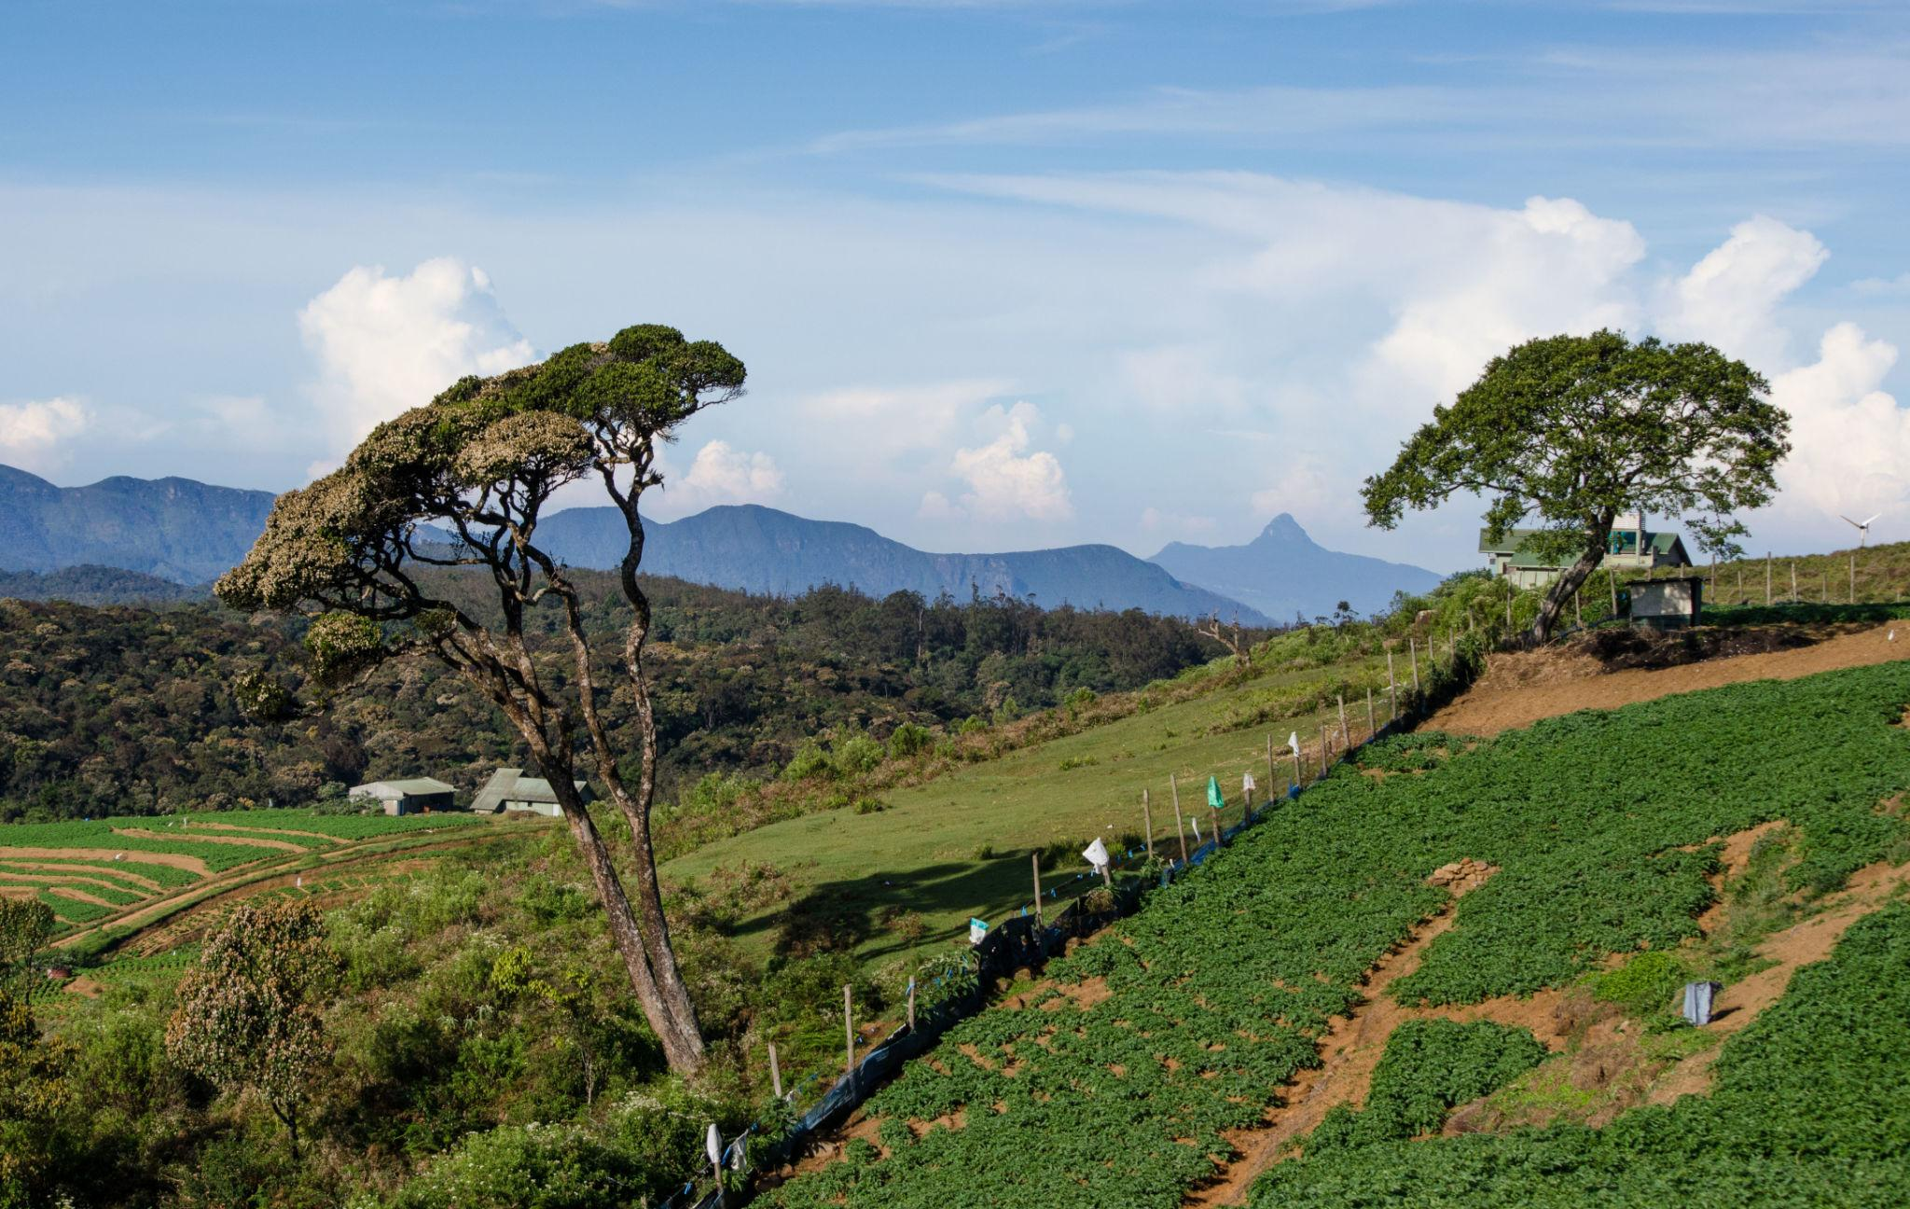
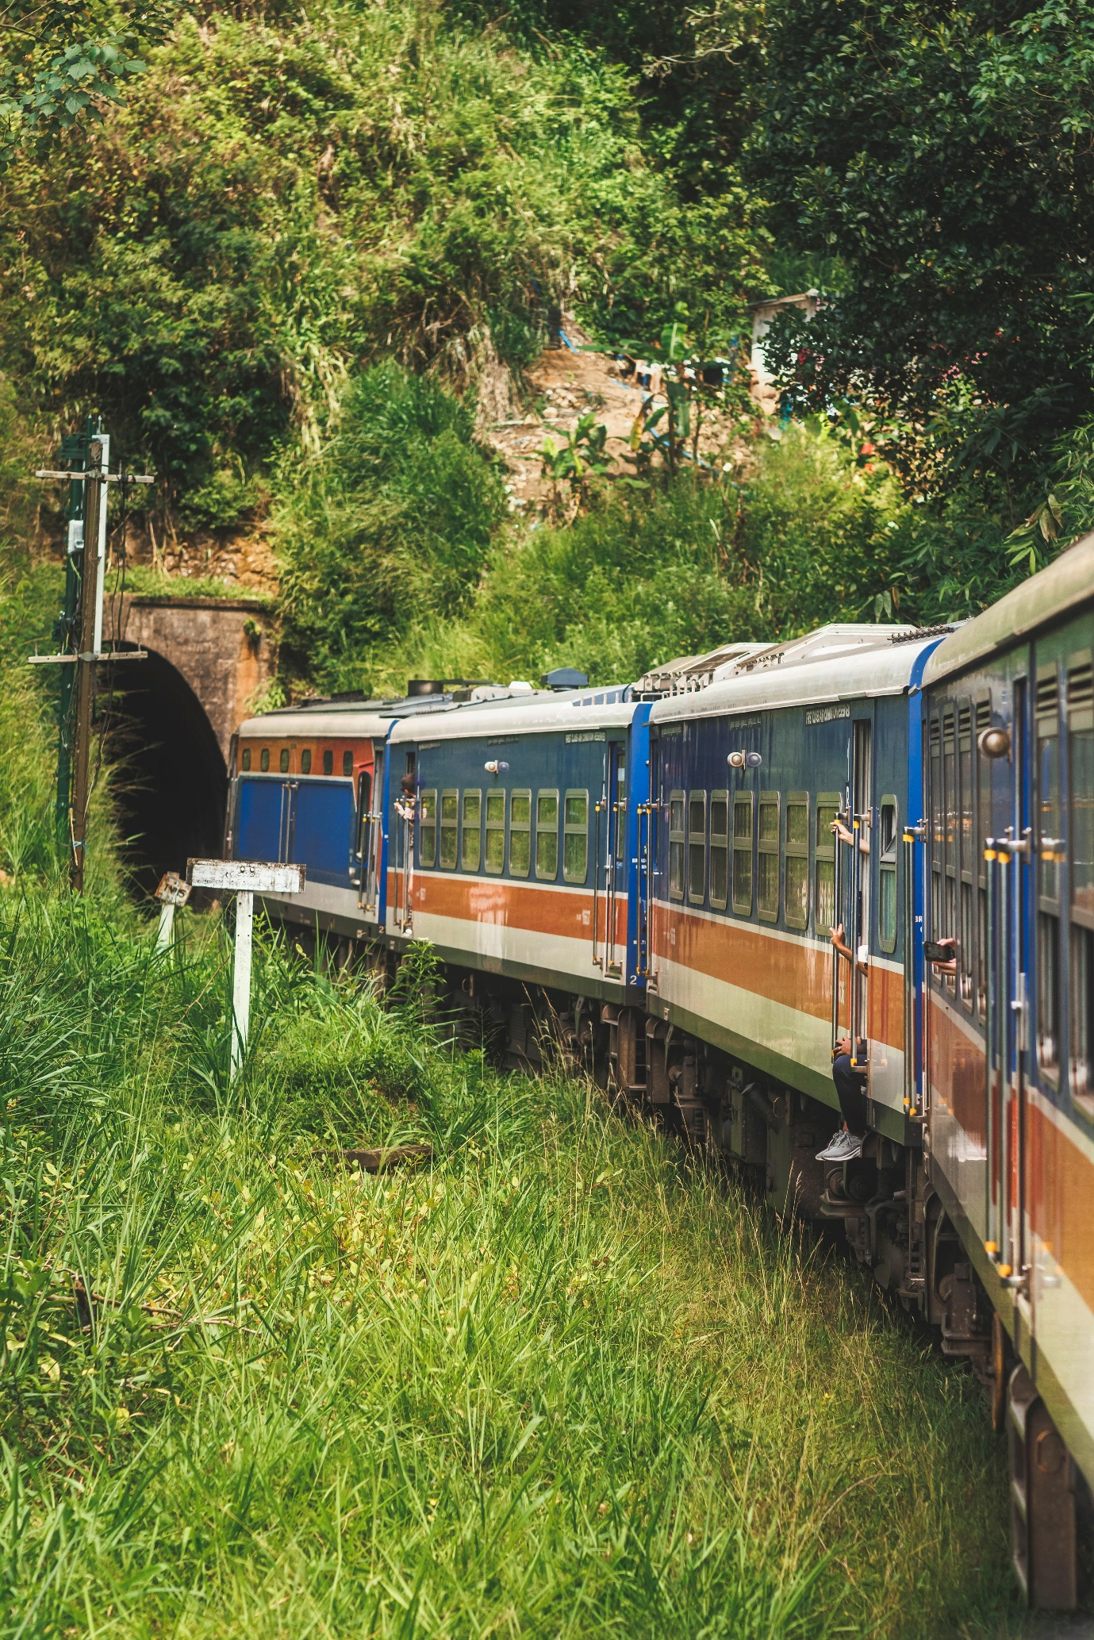
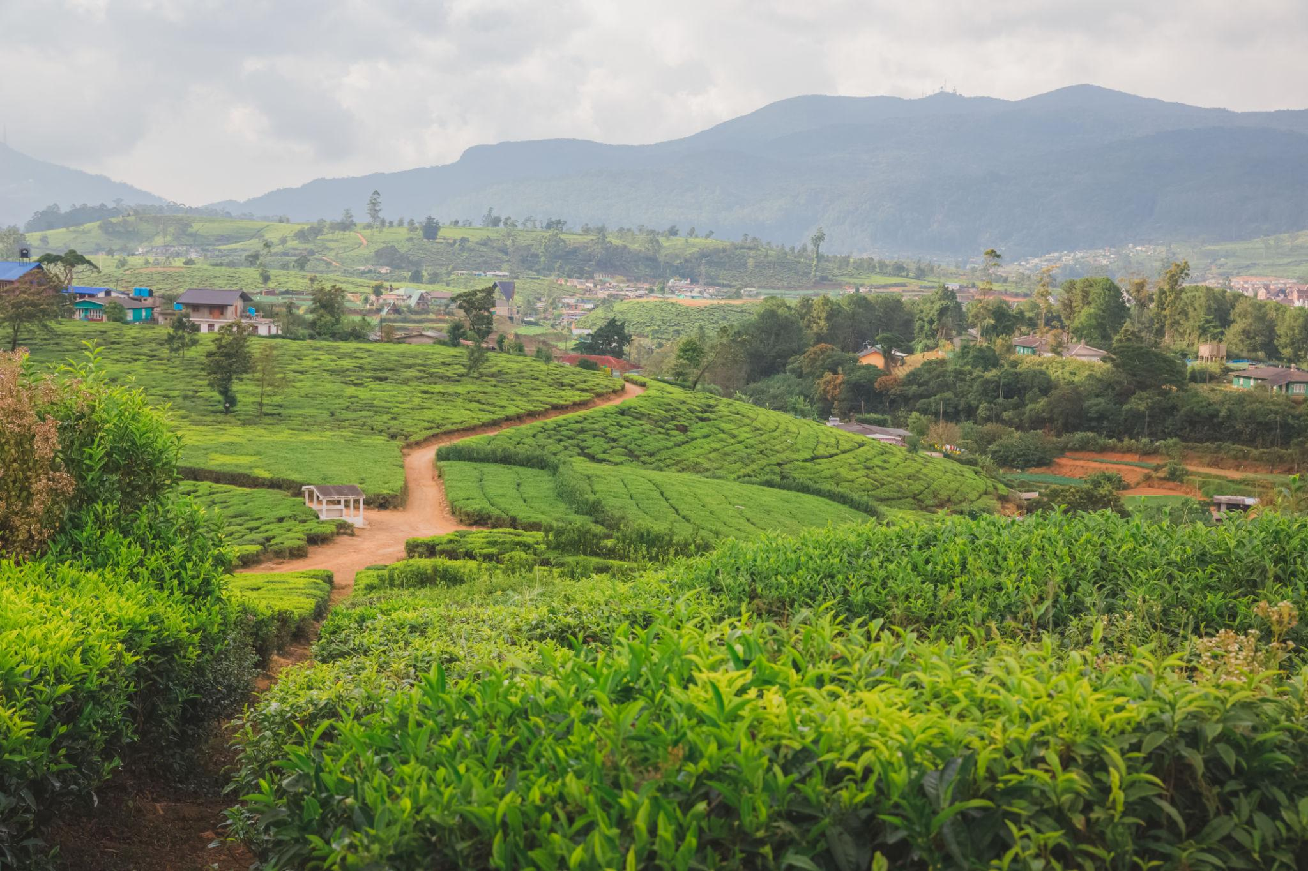
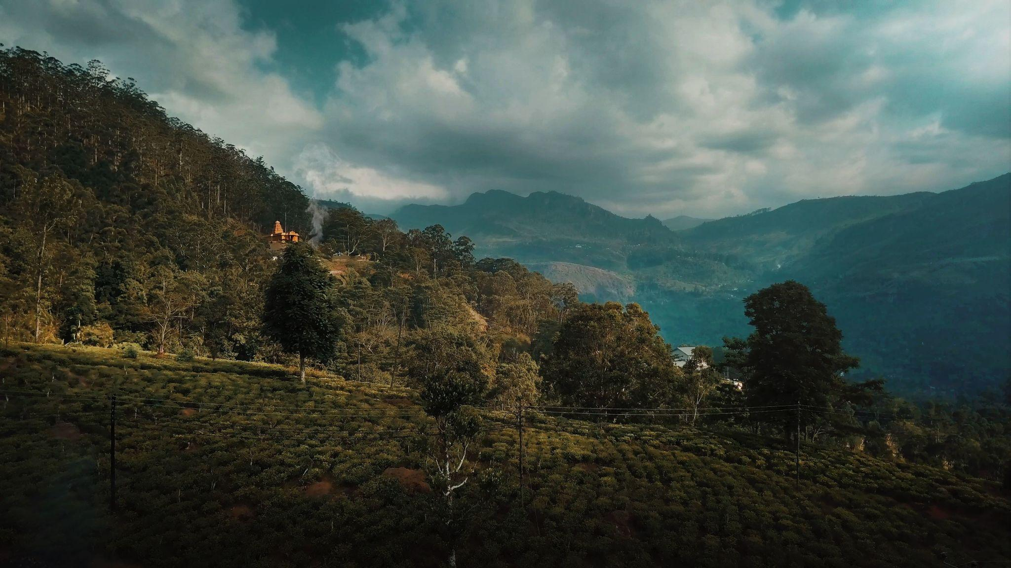

5. Galle
A coastal city famous for beaches and colonial heritage.
Top attractions:
- Galle Fort
- Lighthouse
- Beach cafés
- Boutique hotels
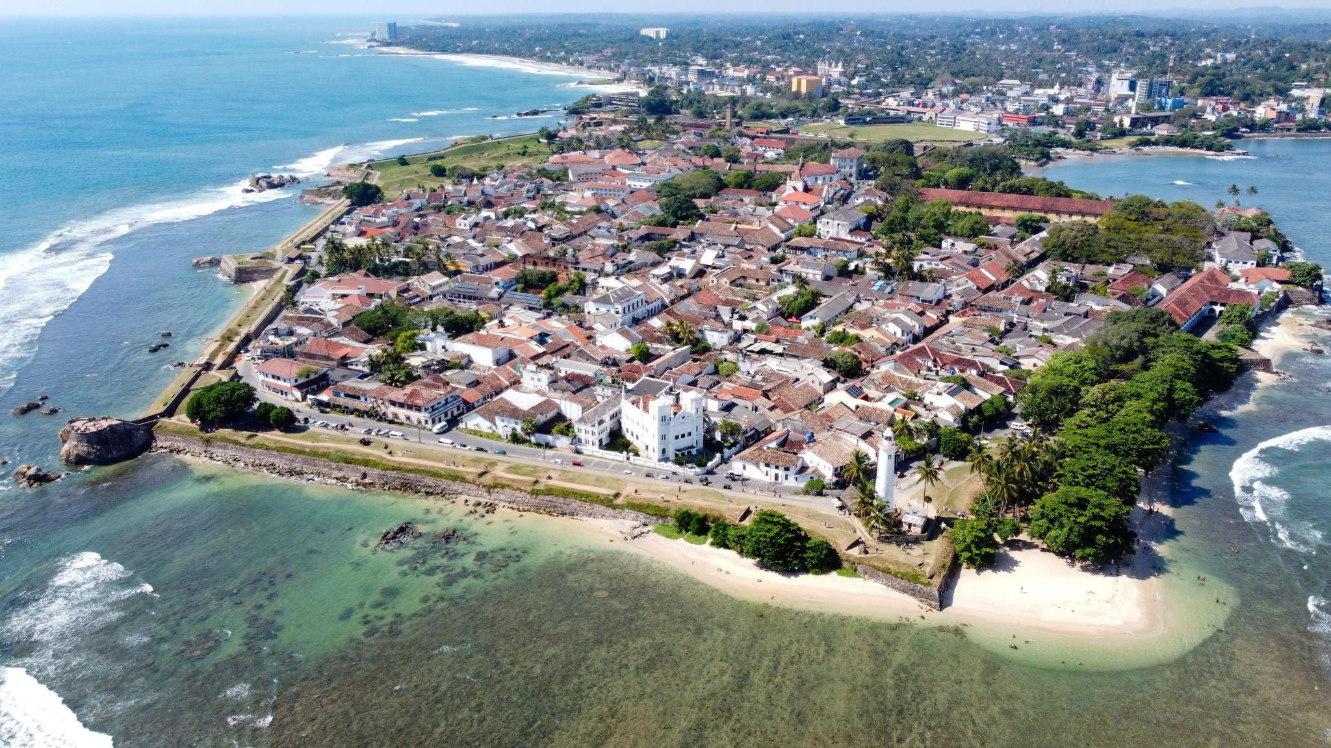
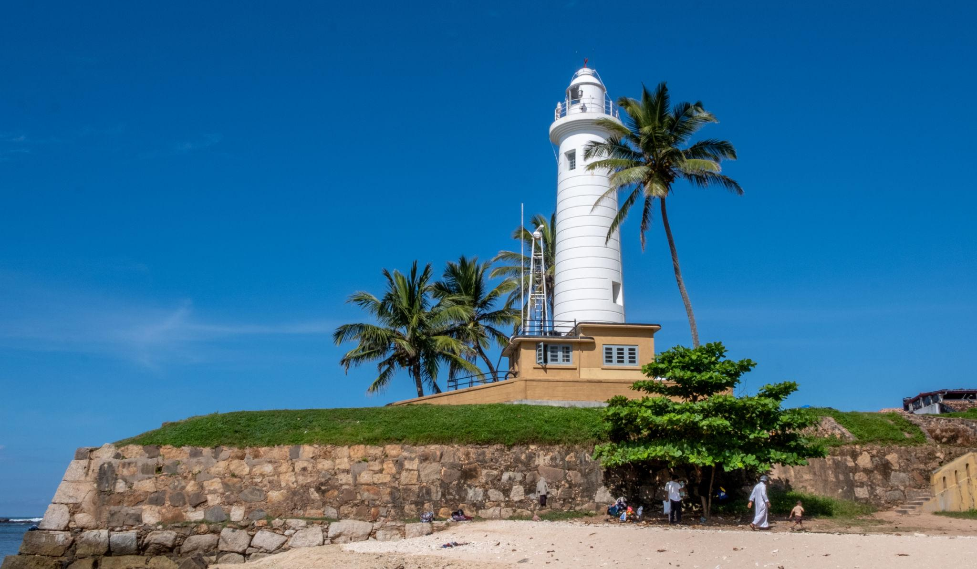
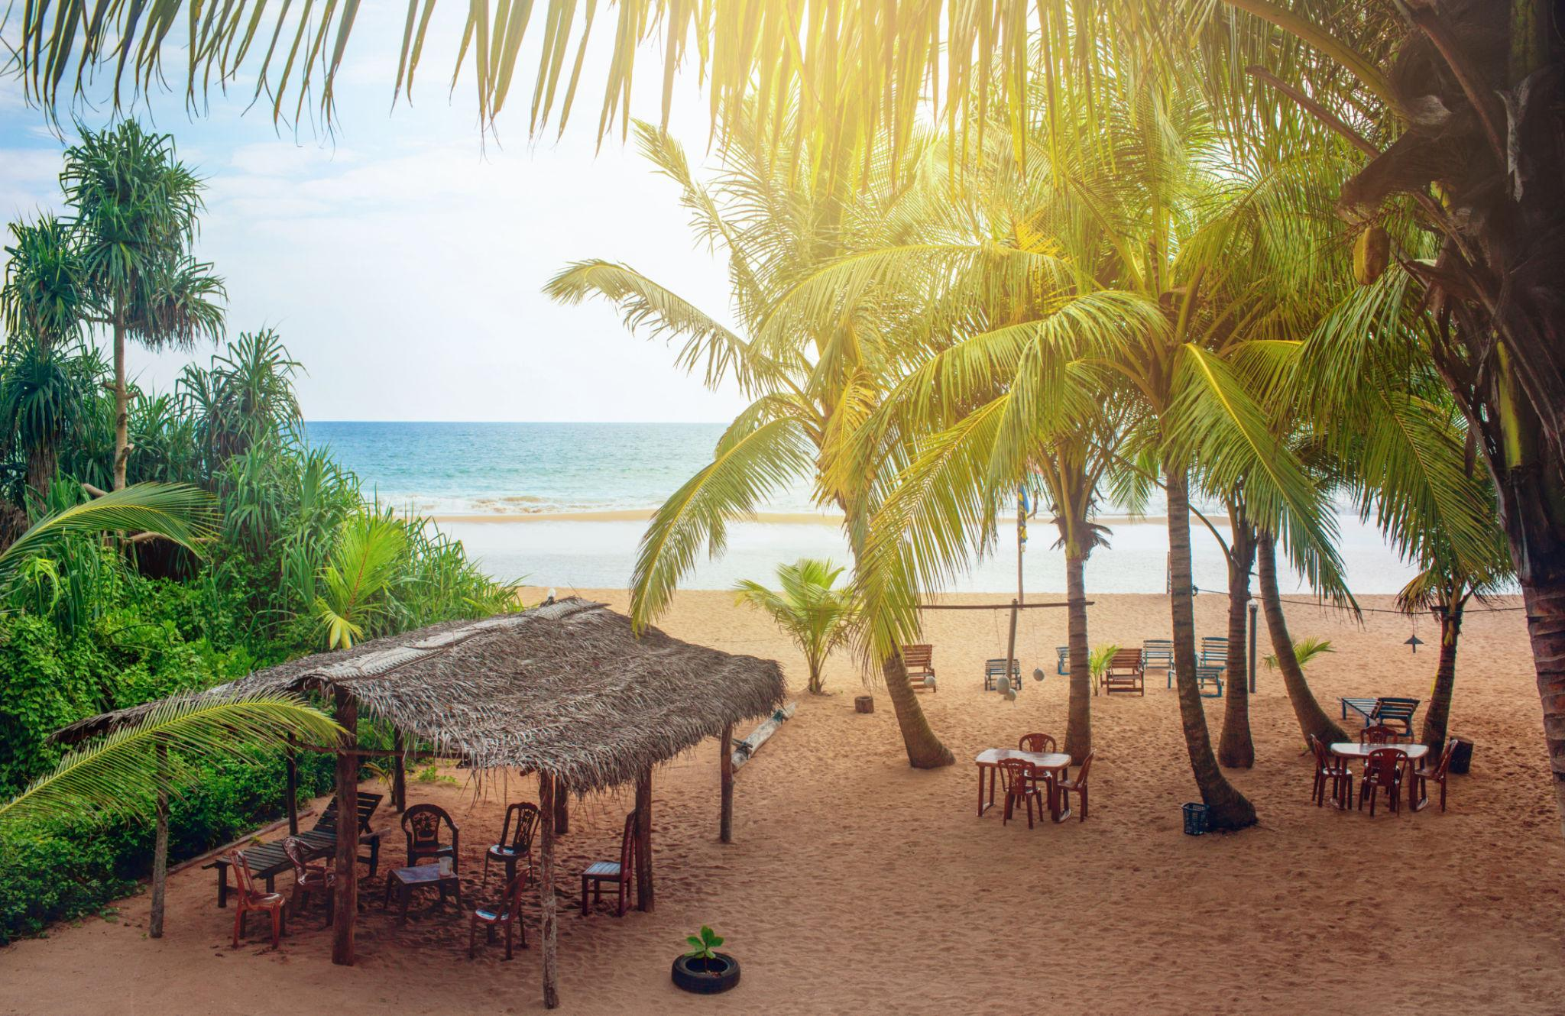
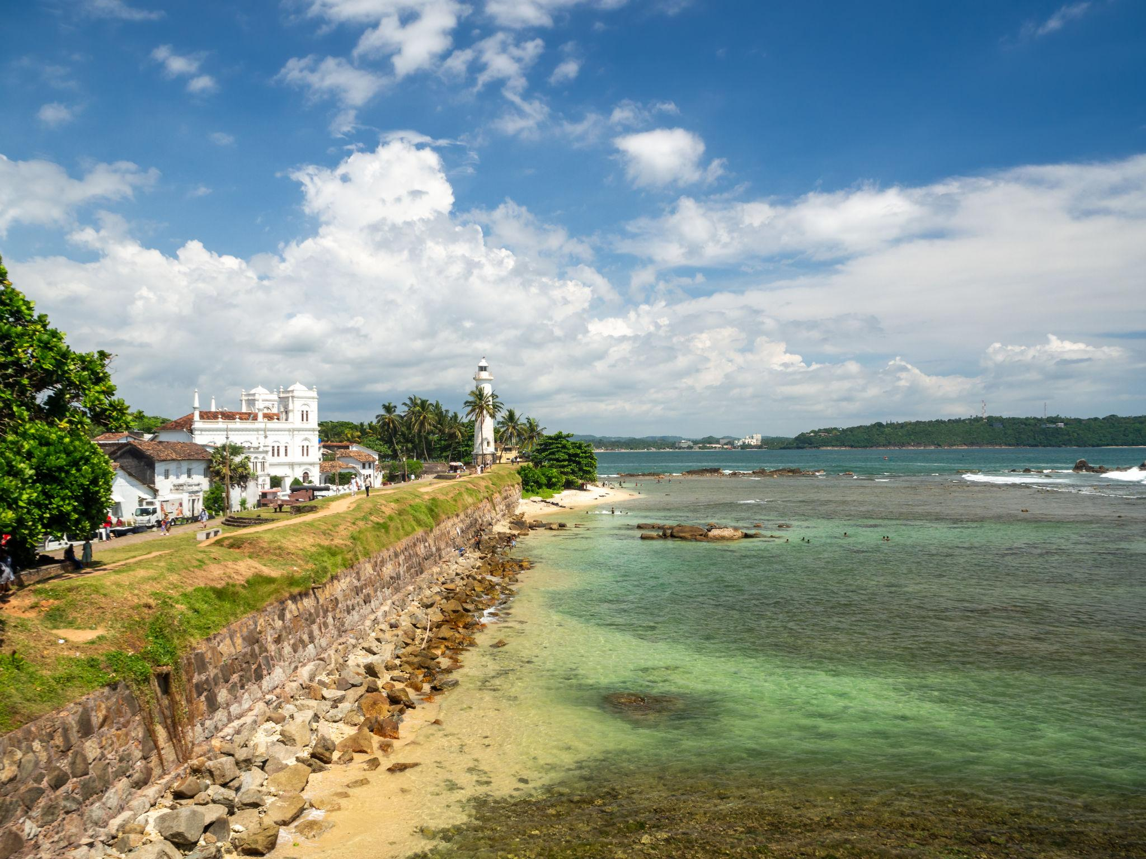
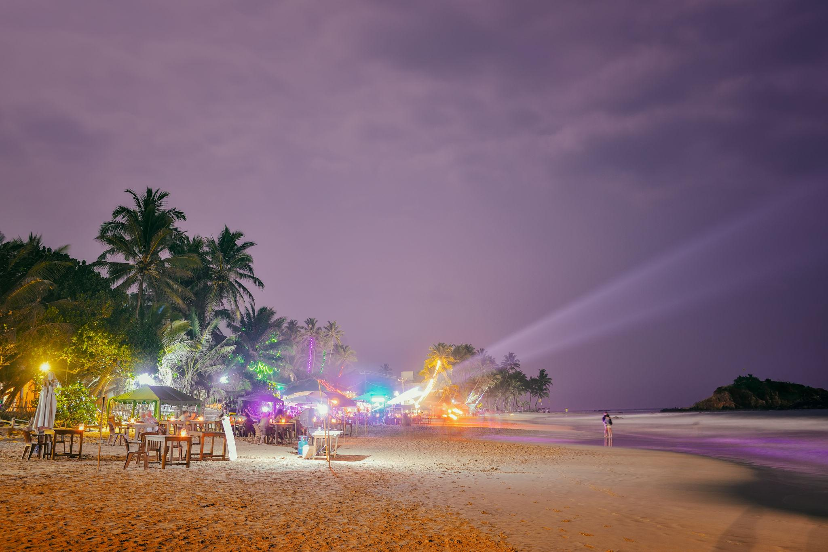
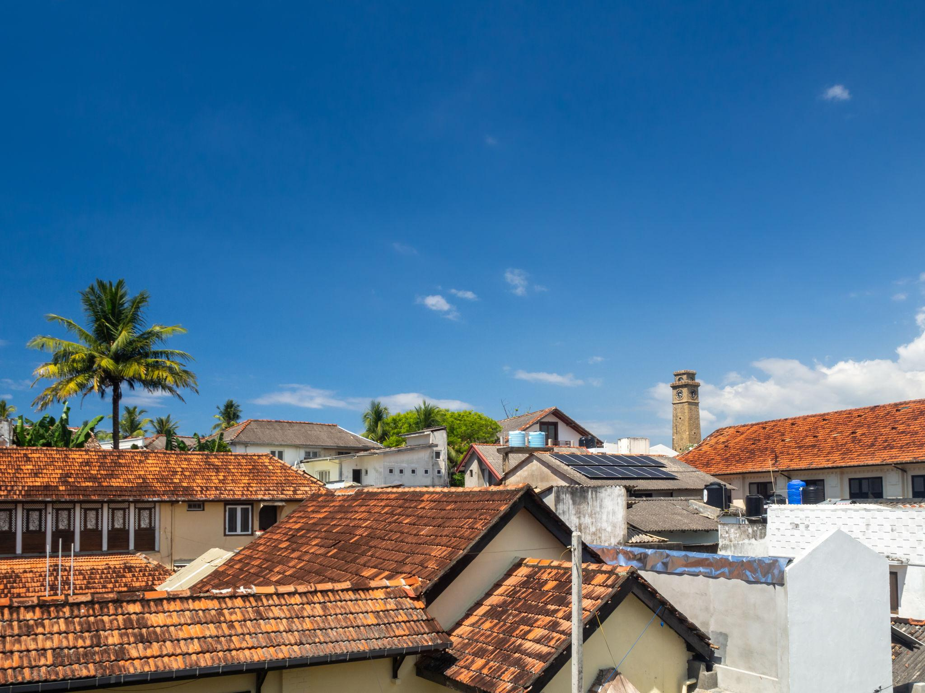
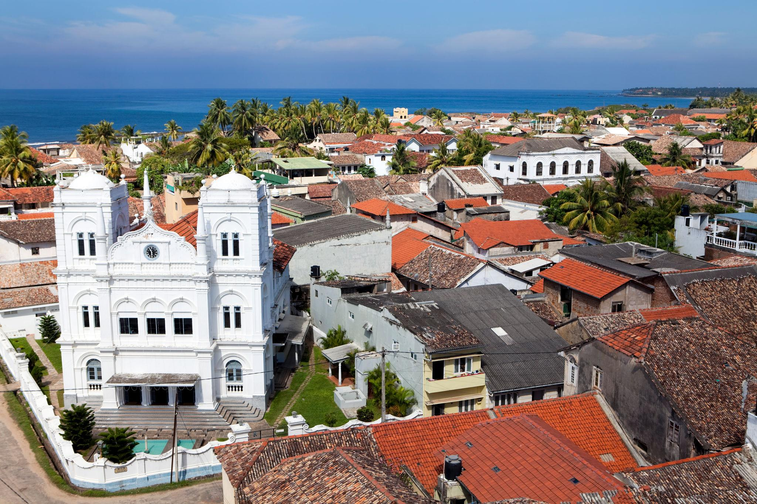

6. Yala National Park
One of the best wildlife safari destinations in Asia.
Wildlife includes:
- Leopards
- Elephants
- Crocodiles
- Exotic birds

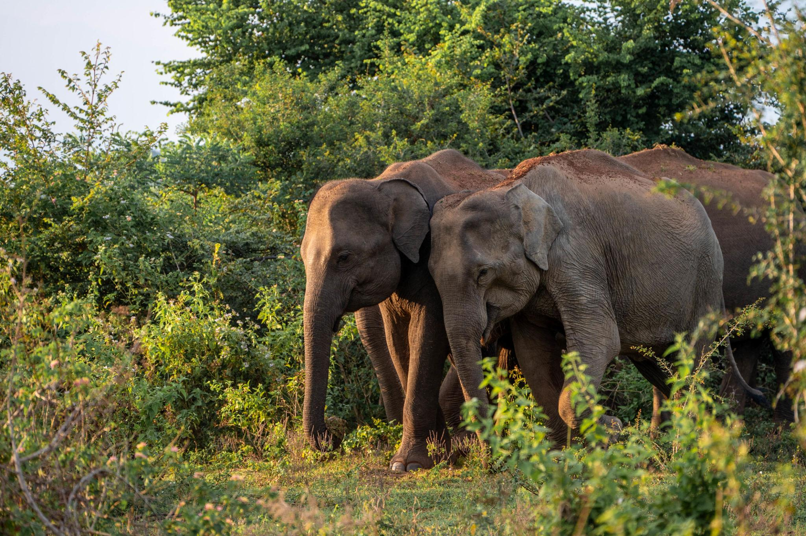
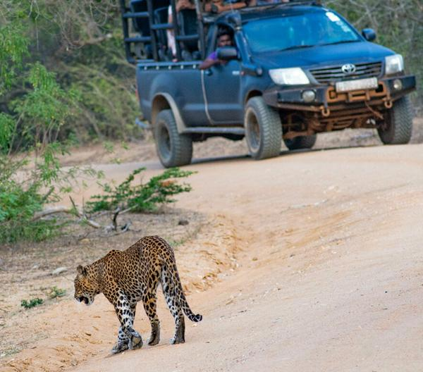
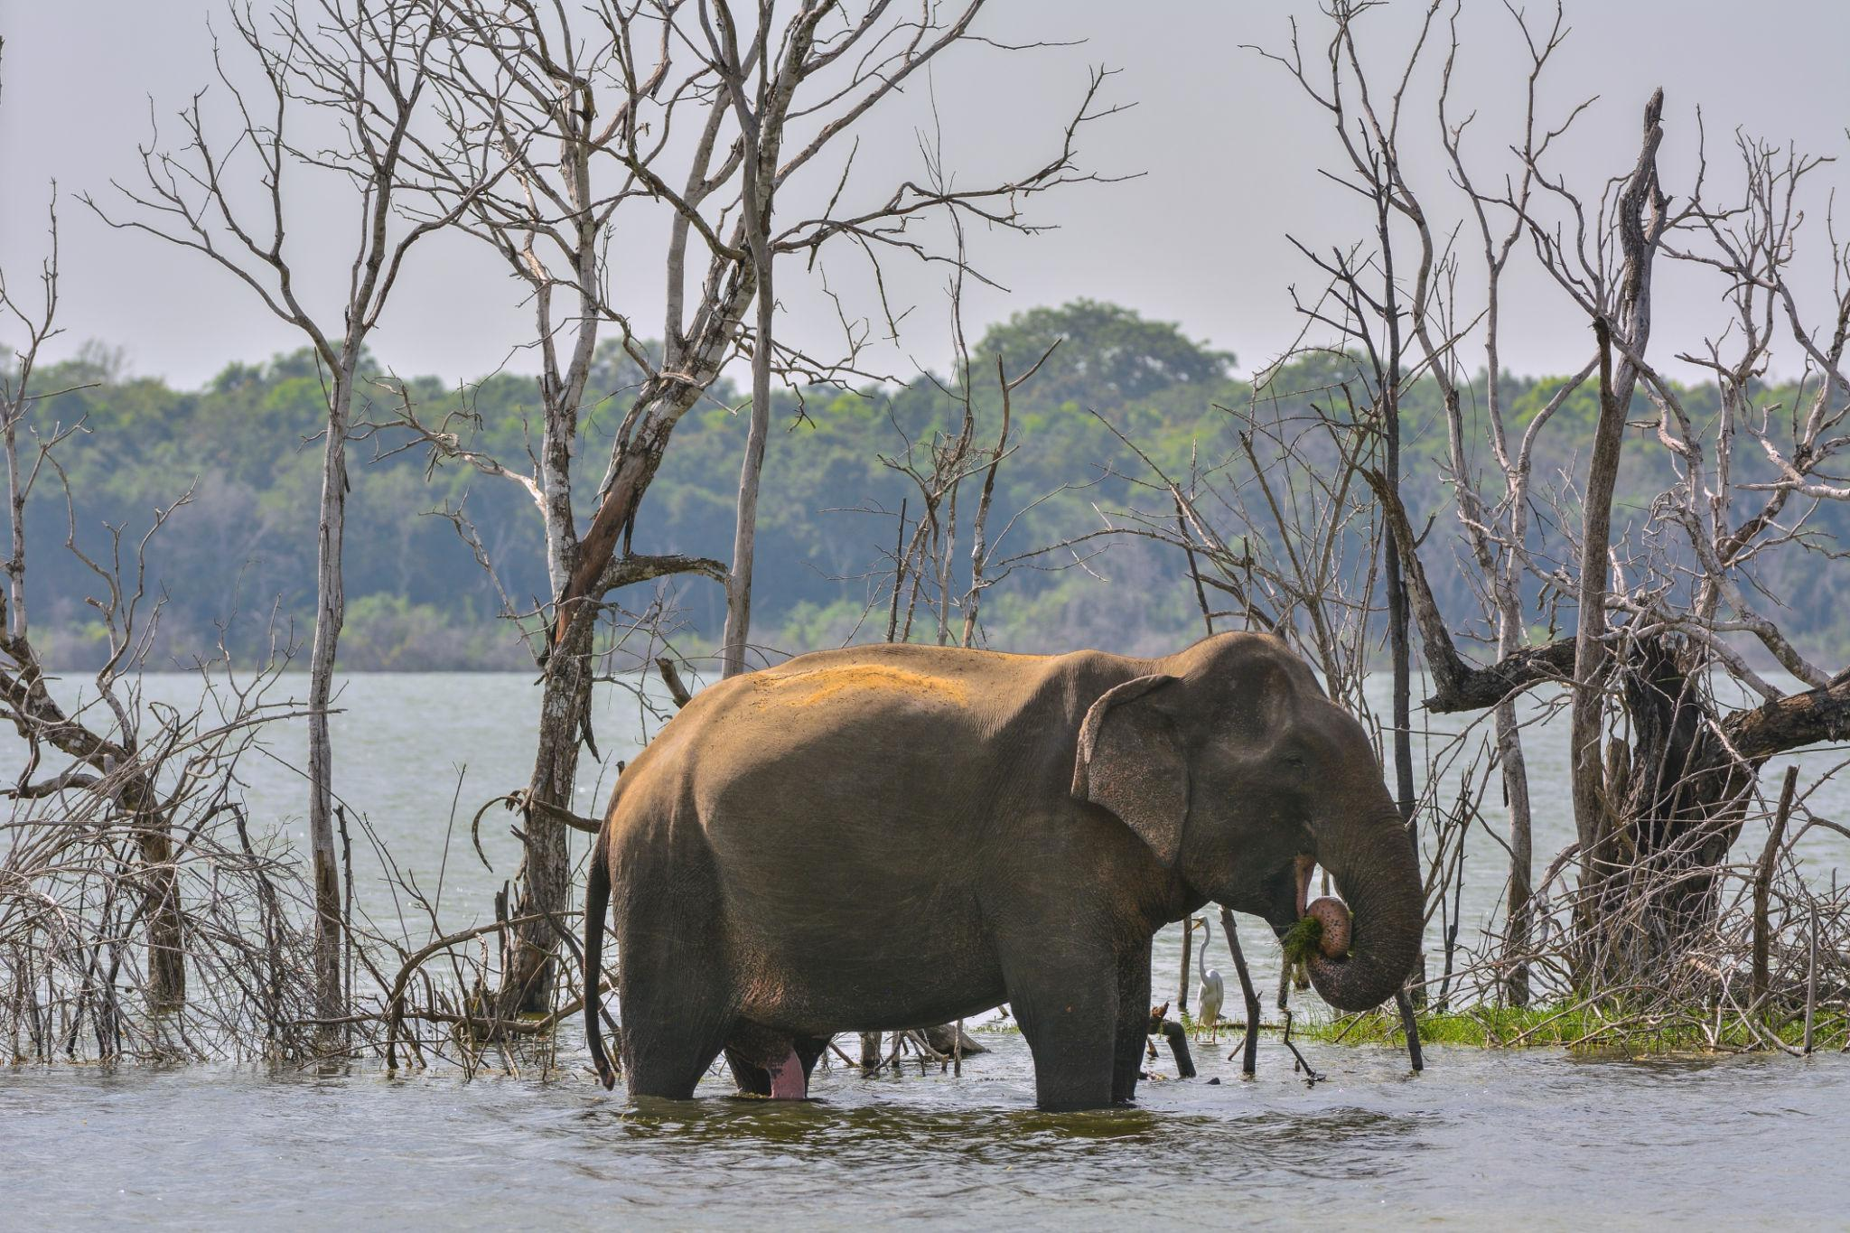
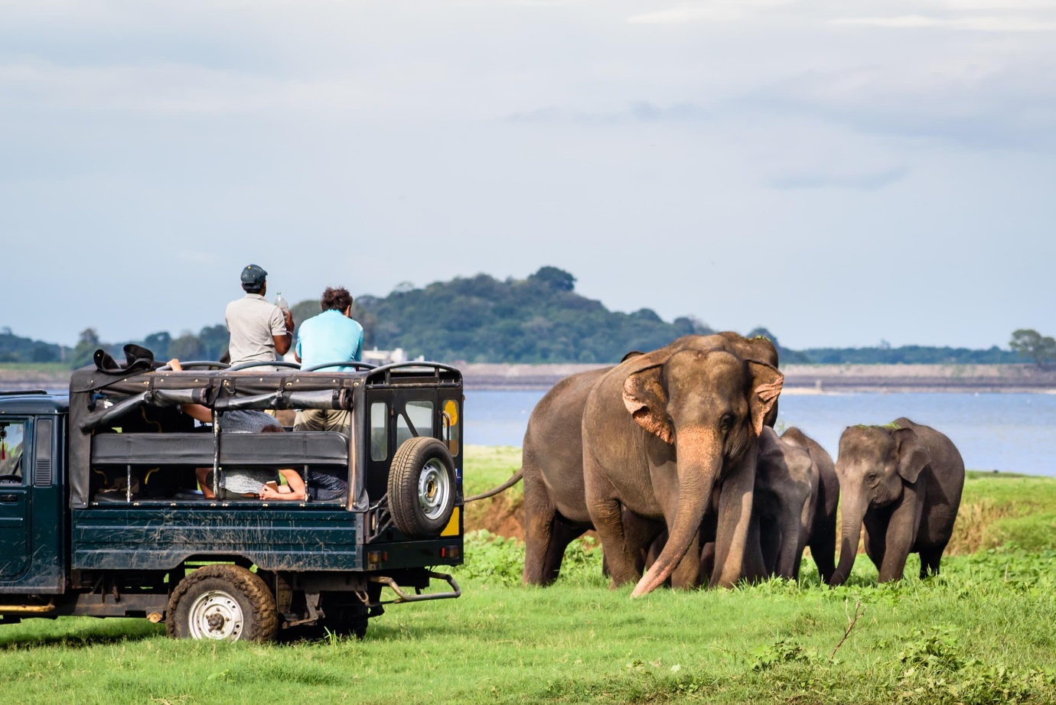
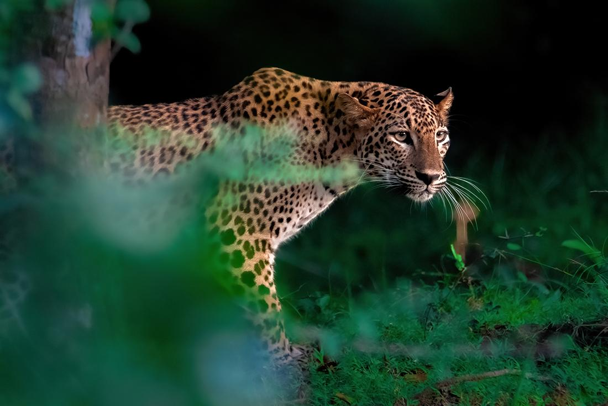
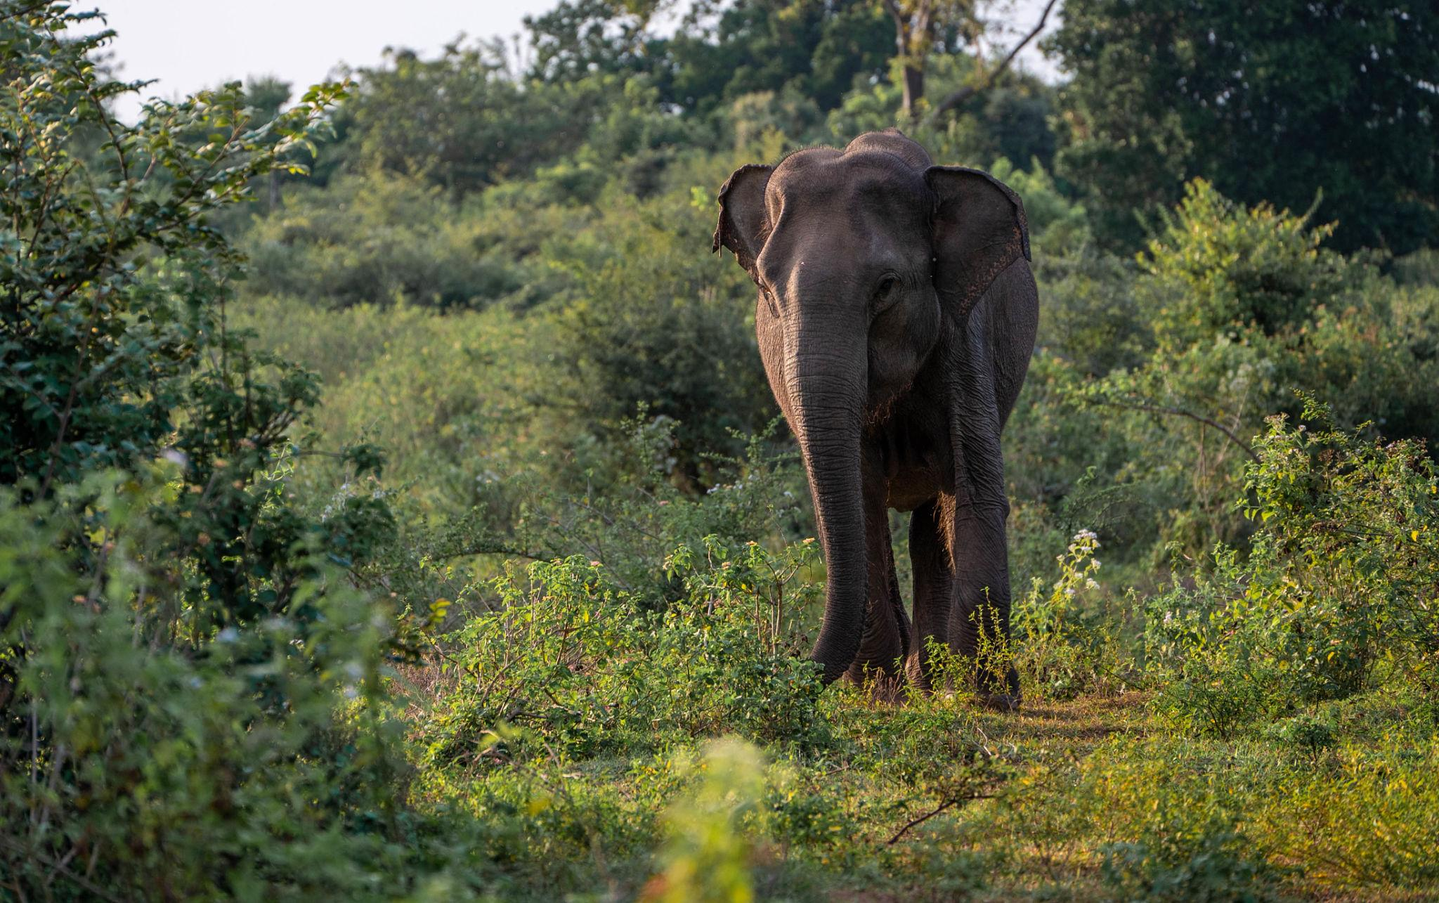

Best Things to Do in Sri Lanka
- Climb Sigiriya Rock Fortress
- Enjoy scenic train rides
- Visit tea plantations
- Go on wildlife safaris
- Relax at beach resorts
- Explore ancient Buddhist temples
- Surf in Mirissa & Bentota
- Watch whales in Mirissa
- Experience Sri Lankan culture & dance
- Shop for tea & handicrafts

Best Time to Visit Sri Lanka
Region | Best Time
West & South Coast | December – April
East Coast | May – September
Hill Country | January – April
Sri Lanka can be visited year-round depending on the region.

Sri Lanka Visa for Indians 🇮🇳
Indian travelers generally require:
- Passport valid for 6 months
- Sri Lanka Visa
- Return flight tickets
- Hotel bookings

Famous Sri Lankan Foods to Try 🍛
- Sri Lankan Rice & Curry
- Hoppers
- Kottu Roti
- String Hoppers
- Seafood Curry
- Ceylon Tea
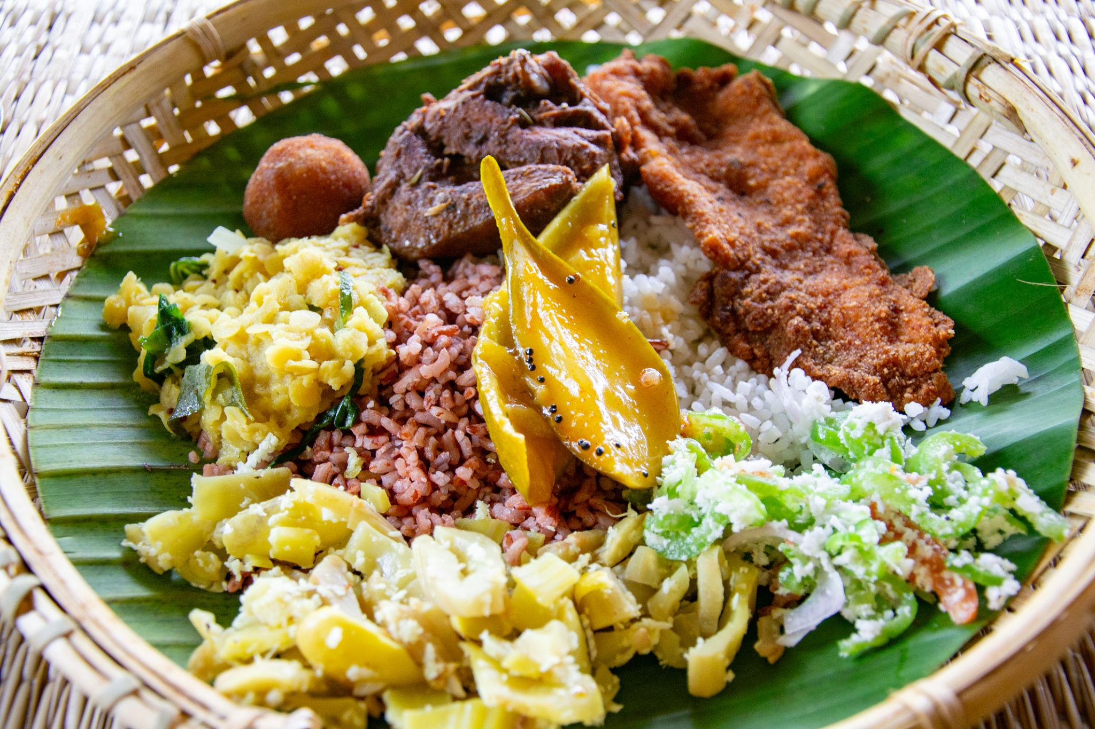
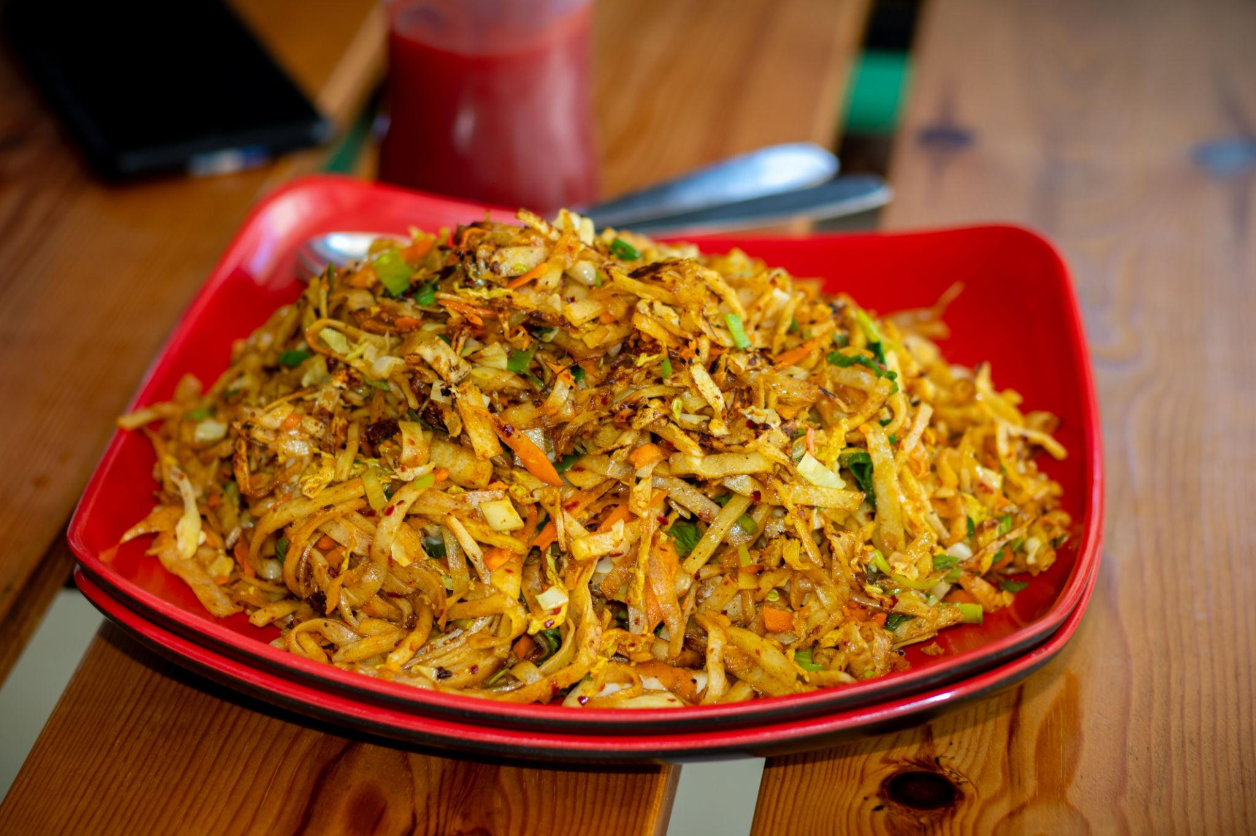
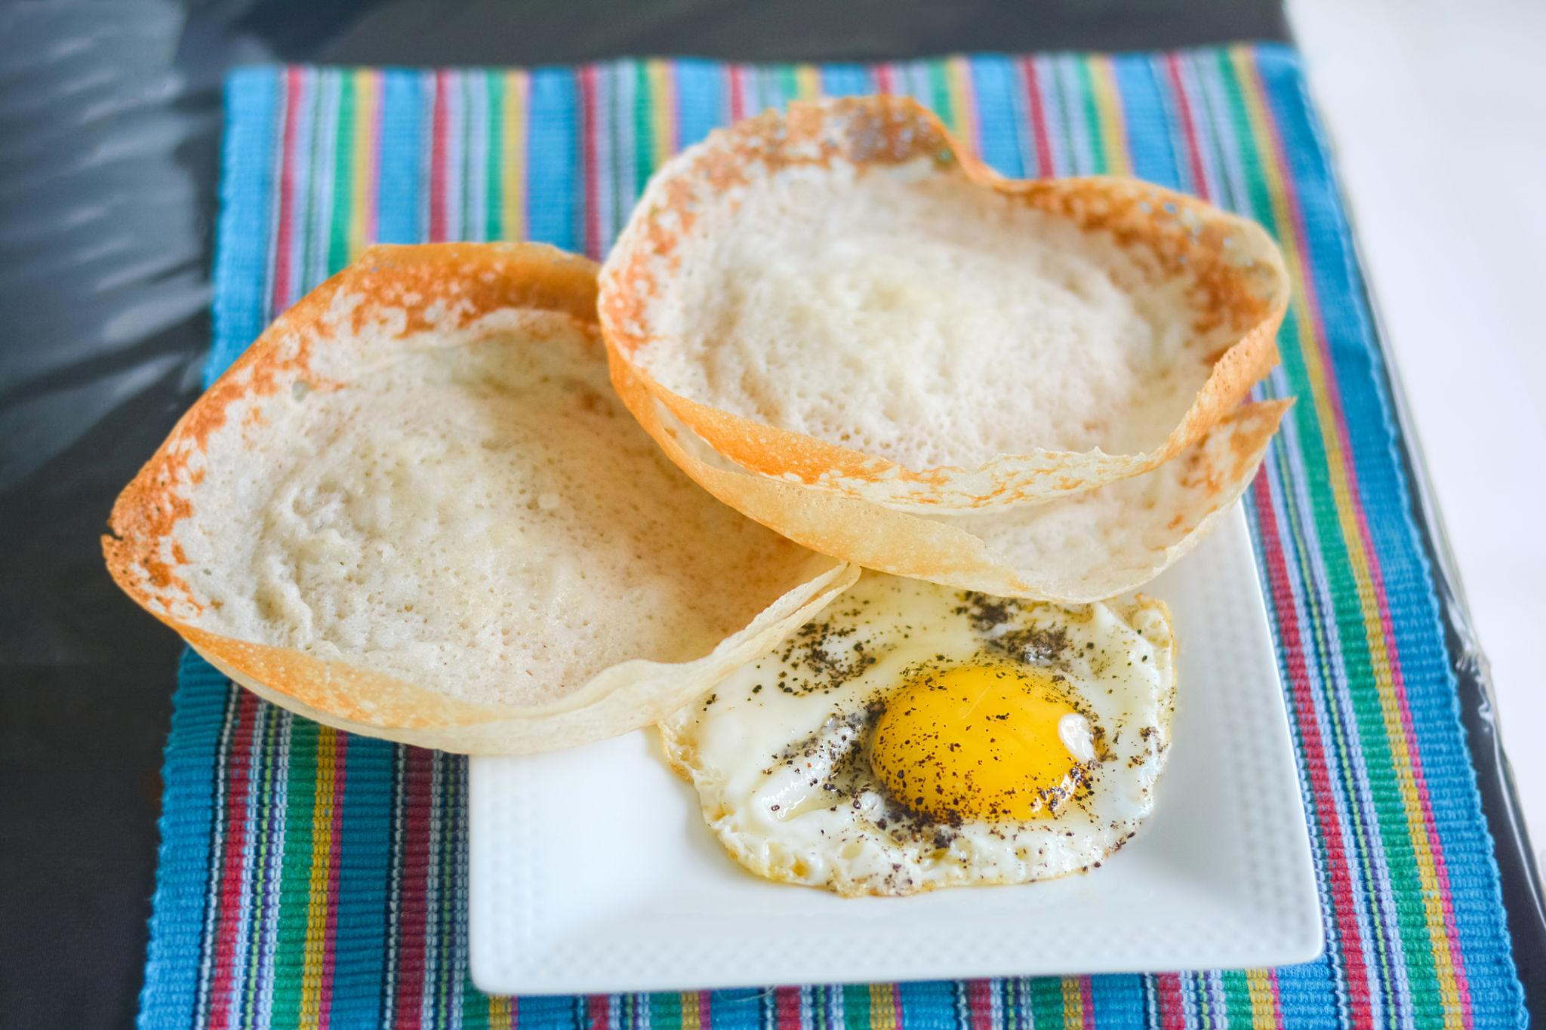
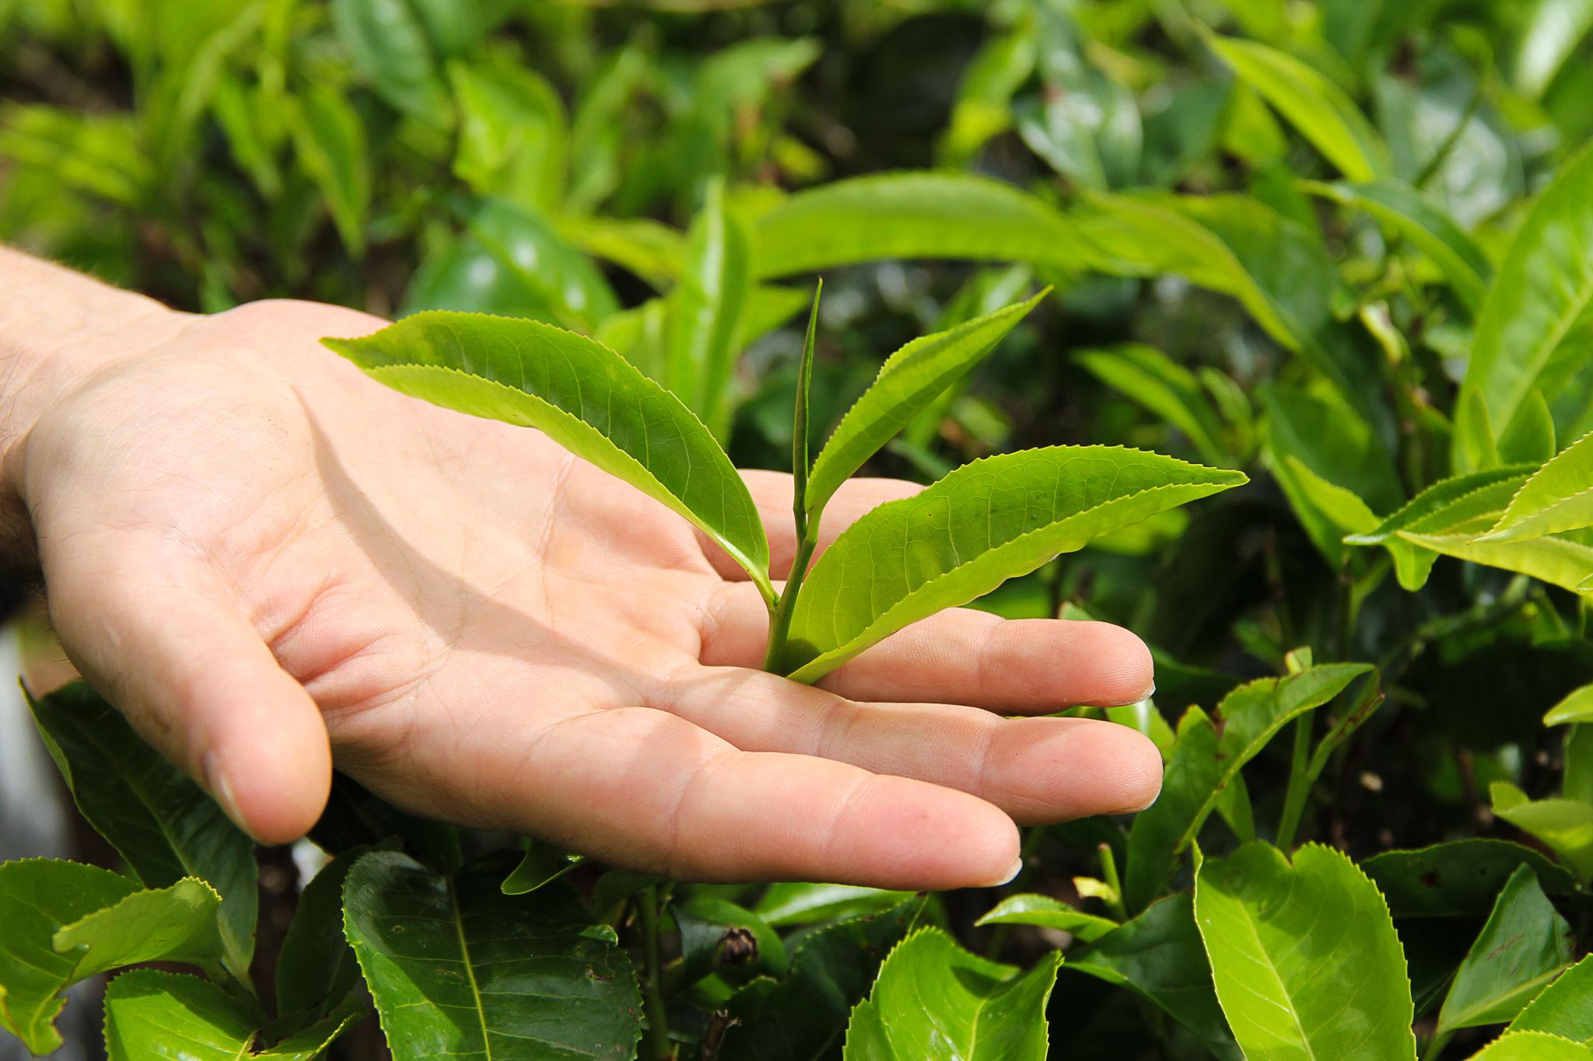
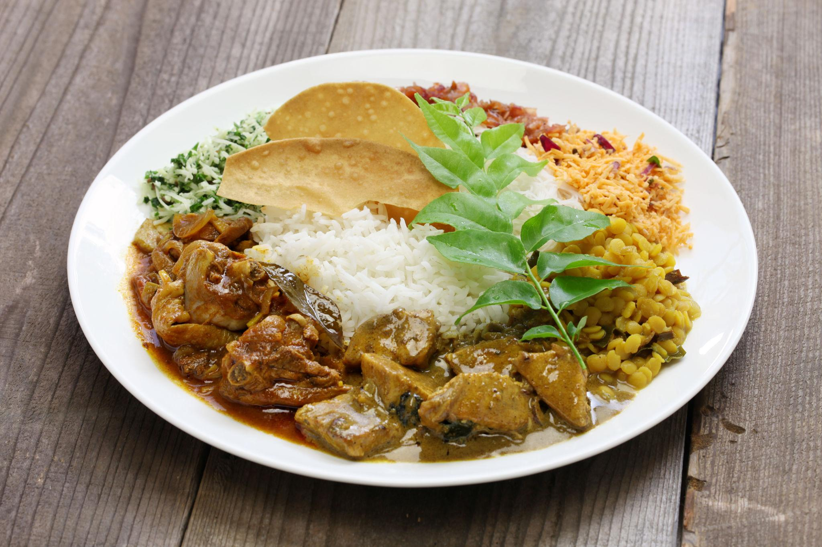
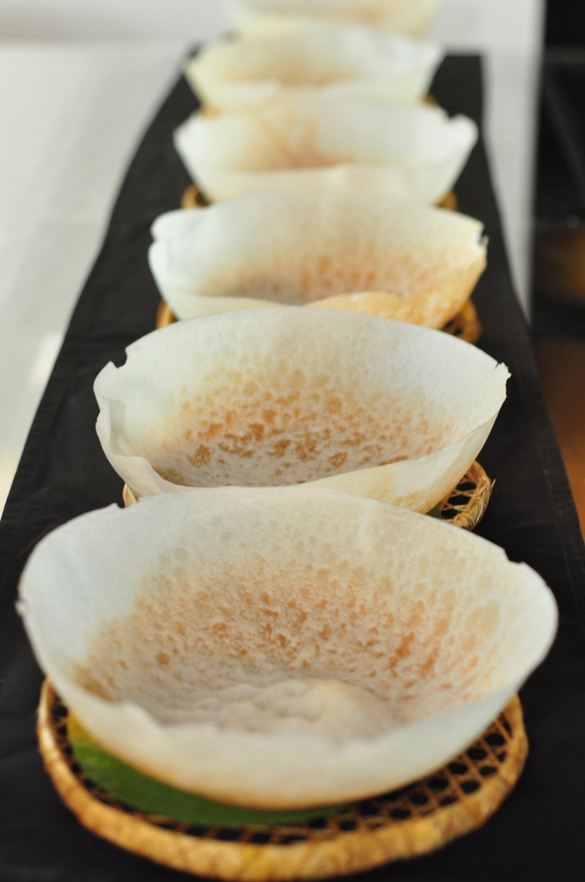

Luxury Experiences in Sri Lanka ✨
- Luxury beach resorts
- Private wildlife safaris
- Scenic train first-class journeys
- Ayurveda spa retreats
- Tea estate luxury stays
- Private whale watching tours
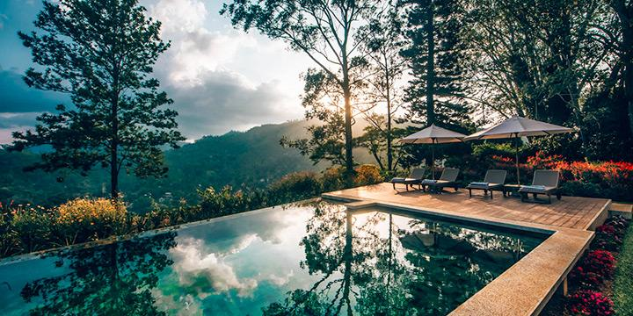
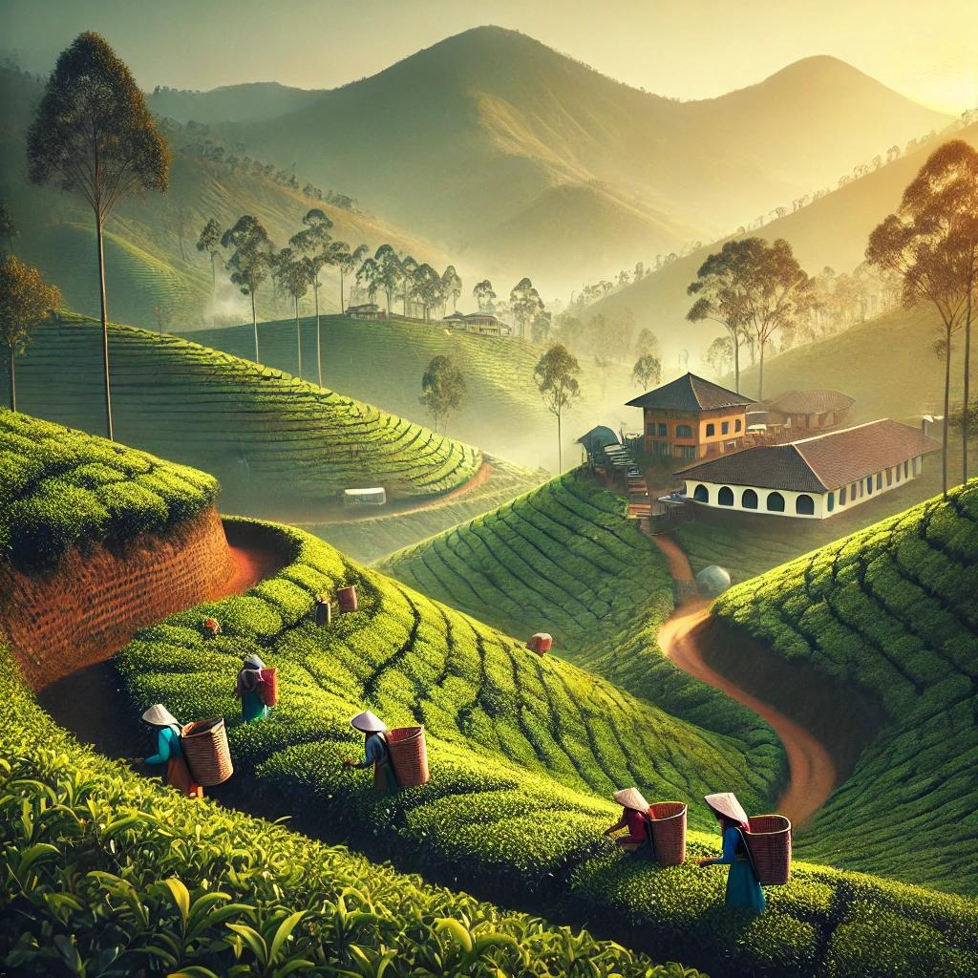
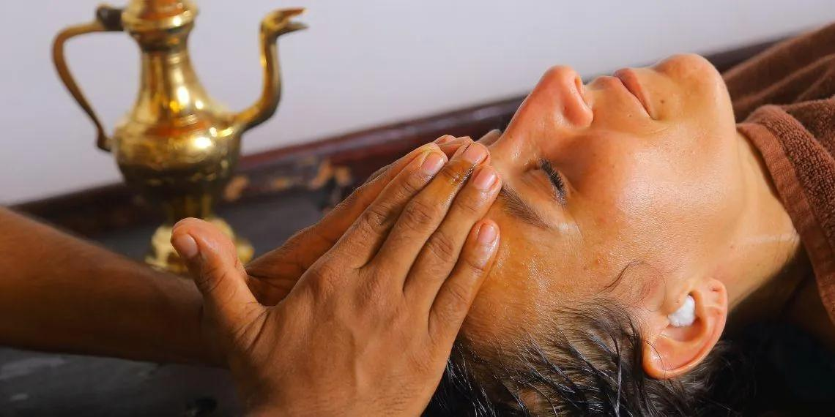
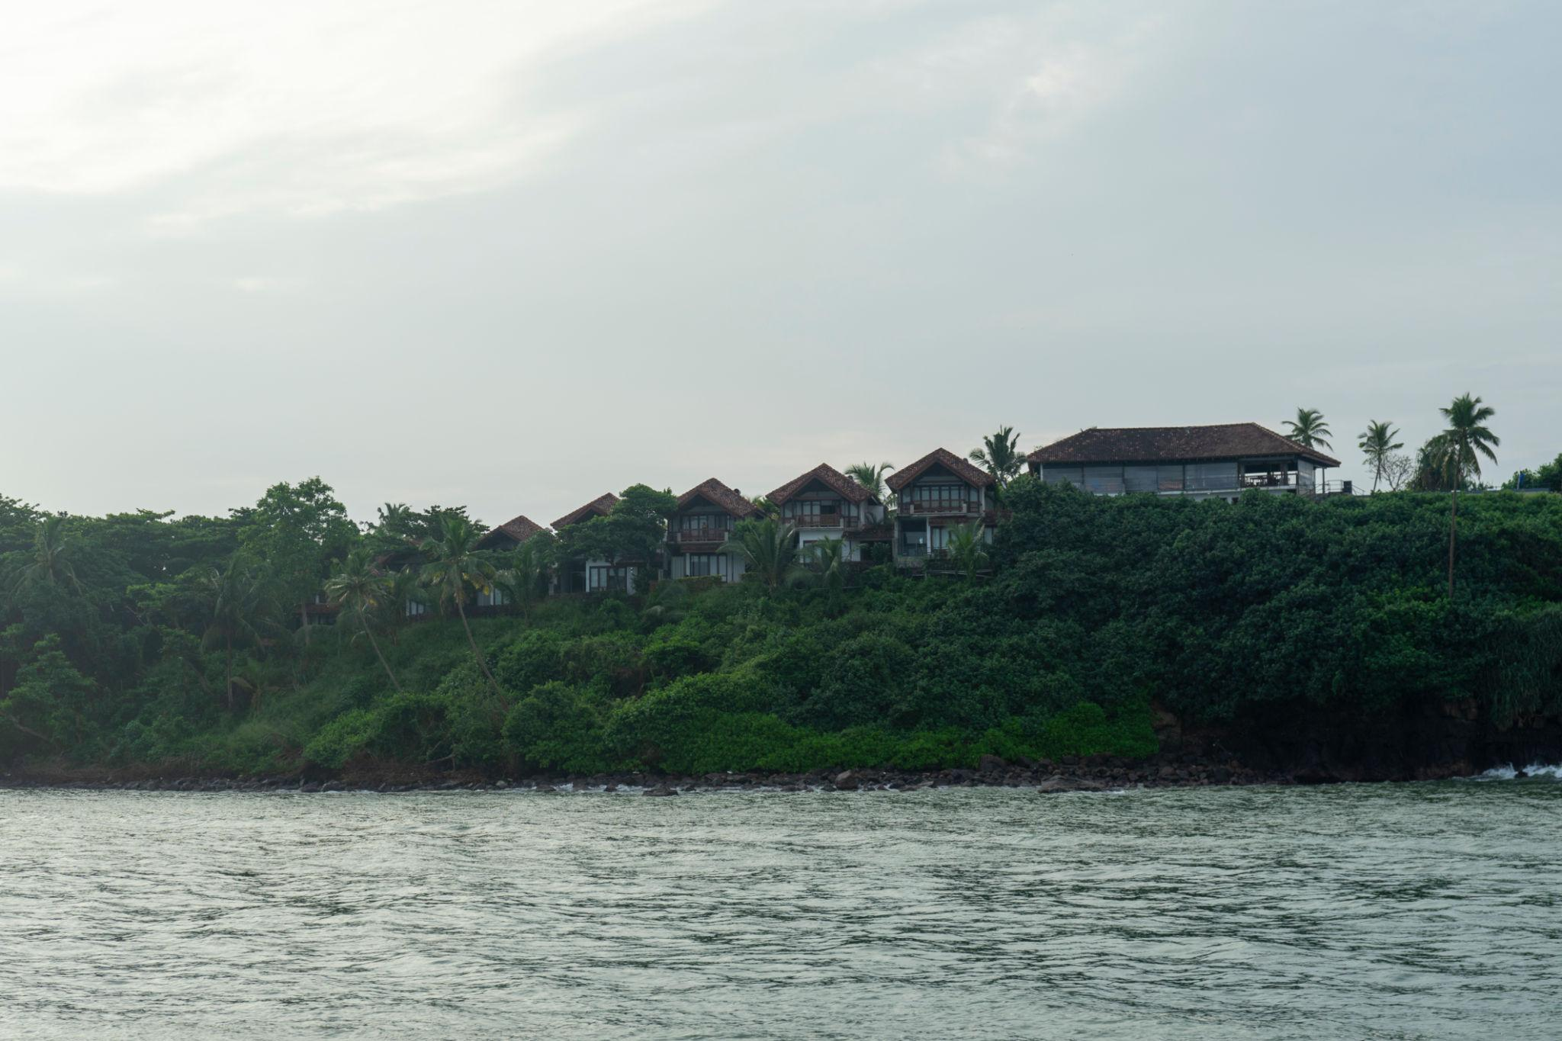

Sri Lanka Travel Tips
- Carry light cotton clothing
- Respect religious sites & dress modestly
- Keep Sri Lankan Rupees for local shopping
- Try local train experiences
- Carry sunscreen & mosquito repellent
- Book safaris and train tickets early

Why Choose INTRO TRAVELS INDIA for Sri Lanka?
With INTRO TRAVELS INDIA, you get:
- Customized Sri Lanka holiday packages
- Honeymoon & family tours
- Budget & luxury hotel options
- Visa assistance
- Airport transfers
- Guided sightseeing tours
- Indian meal options
- Wildlife safari bookings
- Group departures & private tours
Sri Lanka is a destination where tropical beauty, ancient culture, wildlife, beaches, and mountain landscapes come together to create a truly unforgettable travel experience.

